1. **Introduction**

**breast_cancer_model_analysis.R**

Disease prediction has long been regarded as a critical topic. With big data and Machine Learning growth in biomedical and healthcare communities, accurate analysis of medical data benefits early disease detection, patient care, and community services.

1. **Objective**

Build Machine Learning Models to predict the type of Breast Cancer (Malignant or Benign) as well as identify the drivers of cancer.

1. **Approach**

* • Exploring features and Data Preparation which includes missing value treatment and Outlier Detection
* • Visualizing relationships among features
* • Split the data into train and test data and build sophisticated Machine Learning models
* • Evaluating Model performance on test data using Precision, Recall, Accuracy and ROC curve metrics
* • Determining the factors driving the cancer.
* • Choosing best model based on the accuracy and other measures.

**5. Problem Statement**

1. Build Machine Learning Models to predict the type of Breast Cancer (Malignant or Benign) as well as identify the drivers of cancer.

Apply the concepts of - Logistic Regression and Random Forest.

**setwd**("C:/Users/shraddha/Desktop/Acadgild students projects/project4")

**library**(readr)

CancerData <- **read_csv**("CancerData.csv")

## Warning: Missing column names filled in: 'X33' [33] ## Parsed with column specification:

## cols(

## .default = col_double(), ## id = col_integer(),

## diagnosis = col_character(), ## X33 = col_character()

## )

## See spec(...) for full column specifications.

## Warning in rbind(names(probs), probs_f): number of columns of result is not

## a multiple of vector length (arg 1)

## Warning: 569 parsing failures.

## row # A tibble: 5 x 5 col row col expected actual file expected <int> <chr> <chr> <chr> <chr> actual 1 1

<NA> 33 columns 32 columns 'CancerData.csv' file 2 2 <NA> 33 columns 32

columns 'CancerData.csv' row 3 3 <NA> 33 columns 32 columns

'CancerData.csv' col 4 4 <NA> 33 columns 32 columns 'CancerData.csv'

expected 5 5 <NA> 33 columns 32 columns 'CancerData.csv' ## ... ................. ...

.................................................... ........

.................................................... ......

.................................................... ....

.................................................... ...

.................................................... ...

.................................................... ........

....................................................

## See problems(...) for more details.

**View**(CancerData) **summary**(CancerData)

## id diagnosis radius_mean texture_mean ## Min. : 8670 Length:569 Min. : 6.981 Min. : 9.71

## 1st Qu.: 869218 Class :character 1st Qu.:11.700 1st Qu.:16.17 ## Median : 906024 Mode :character Median :13.370 Median :18.84 ## Mean : 30371831 Mean :14.127 Mean :19.29

## 3rd Qu.: 8813129 3rd Qu.:15.780 3rd Qu.:21.80

## Max. :911320502 Max. :28.110 Max. :39.28

## perimeter_mean area_mean smoothness_mean compactness_mean ## Min. : 43.79 Min. : 143.5 Min. :0.05263 Min. :0.01938 ## 1st Qu.: 75.17 1st Qu.: 420.3 1st Qu.:0.08637 1st Qu.:0.06492

## Median : 86.24 Median : 551.1 Median :0.09587 Median :0.09263

## Mean : 91.97 Mean : 654.9 Mean :0.09636 Mean :0.10434 ## 3rd Qu.:104.10 3rd Qu.: 782.7 3rd Qu.:0.10530 3rd Qu.:0.13040 ## Max. :188.50 Max. :2501.0 Max. :0.16340 Max. :0.34540

## concavity_mean concave points_mean symmetry_mean ## Min. :0.00000 Min. :0.00000 Min. :0.1060 ## 1st Qu.:0.02956 1st Qu.:0.02031 1st Qu.:0.1619

## Median :0.06154 Median :0.03350 Median :0.1792

## Mean :0.08880 Mean :0.04892 Mean :0.1812 ## 3rd Qu.:0.13070 3rd Qu.:0.07400 3rd Qu.:0.1957 ## Max. :0.42680 Max. :0.20120 Max. :0.3040

## fractal_dimension_mean radius_se texture_se perimeter_se ## Min. :0.04996 Min. :0.1115 Min. :0.3602 Min. : 0.757 ## 1st Qu.:0.05770 1st Qu.:0.2324 1st Qu.:0.8339 1st Qu.: 1.606

## Median :0.06154 Median :0.3242 Median :1.1080 Median : 2.287

## Mean :0.06280 Mean :0.4052 Mean :1.2169 Mean : 2.866

## 3rd Qu.:0.06612 3rd Qu.:0.4789 3rd Qu.:1.4740 3rd Qu.: 3.357 ## Max. :0.09744 Max. :2.8730 Max. :4.8850 Max. :21.980

## area_se smoothness_se compactness_se concavity_se ## Min. : 6.802 Min. :0.001713 Min. :0.002252 Min. :0.00000 ## 1st Qu.: 17.850 1st Qu.:0.005169 1st Qu.:0.013080 1st Qu.:0.01509

## Median : 24.530 Median :0.006380 Median :0.020450 Median :0.02589

## Mean : 40.337 Mean :0.007041 Mean :0.025478 Mean :0.03189 ## 3rd Qu.: 45.190 3rd Qu.:0.008146 3rd Qu.:0.032450 3rd Qu.:0.04205 ## Max. :542.200 Max. :0.031130 Max. :0.135400 Max. :0.39600

## concave points_se symmetry_se fractal_dimension_se ## Min. :0.000000 Min. :0.007882 Min. :0.0008948 ## 1st Qu.:0.007638 1st Qu.:0.015160 1st Qu.:0.0022480

## Median :0.010930 Median :0.018730 Median :0.0031870

## Mean :0.011796 Mean :0.020542 Mean :0.0037949 ## 3rd Qu.:0.014710 3rd Qu.:0.023480 3rd Qu.:0.0045580 ## Max. :0.052790 Max. :0.078950 Max. :0.0298400

## radius_worst texture_worst perimeter_worst area_worst ## Min. : 7.93 Min. :12.02 Min. : 50.41 Min. : 185.2 ## 1st Qu.:13.01 1st Qu.:21.08 1st Qu.: 84.11 1st Qu.: 515.3

## Median :14.97 Median :25.41 Median : 97.66 Median : 686.5

## Mean :16.27 Mean :25.68 Mean :107.26 Mean : 880.6 ## 3rd Qu.:18.79 3rd Qu.:29.72 3rd Qu.:125.40 3rd Qu.:1084.0 ## Max. :36.04 Max. :49.54 Max. :251.20 Max. :4254.0

## smoothness_worst compactness_worst concavity_worst concave points_worst ## Min. :0.07117 Min. :0.02729 Min. :0.0000 Min. :0.00000

## 1st Qu.:0.11660 1st Qu.:0.14720 1st Qu.:0.1145 1st Qu.:0.06493

## Median :0.13130 Median :0.21190 Median :0.2267 Median :0.09993

## Mean :0.13237 Mean :0.25427 Mean :0.2722 Mean :0.11461 ## 3rd Qu.:0.14600 3rd Qu.:0.33910 3rd Qu.:0.3829 3rd Qu.:0.16140 ## Max. :0.22260 Max. :1.05800 Max. :1.2520 Max. :0.29100

## symmetry_worst fractal_dimension_worst X33 ## Min. :0.1565 Min. :0.05504 Length:569

## 1st Qu.:0.2504 1st Qu.:0.07146 Class :character ## Median :0.2822 Median :0.08004 Mode :character ## Mean :0.2901 Mean :0.08395

## 3rd Qu.:0.3179 3rd Qu.:0.09208 ## Max. :0.6638 Max. :0.20750

**dim**(CancerData)

## [1] 569 33

**names**(CancerData)

## [1] "id" "diagnosis"

## [3] "radius_mean" "texture_mean"

## [5] "perimeter_mean" "area_mean"

## [7] "smoothness_mean" "compactness_mean" ## [9] "concavity_mean" "concave points_mean"

## [11] "symmetry_mean" "fractal_dimension_mean" ## [13] "radius_se" "texture_se"

## [15] "perimeter_se" "area_se"

## [17] "smoothness_se" "compactness_se"

## [19] "concavity_se" "concave points_se"

## [21] "symmetry_se" "fractal_dimension_se"

## [23] "radius_worst" "texture_worst" ## [25] "perimeter_worst" "area_worst"

## [27] "smoothness_worst" "compactness_worst" ## [29] "concavity_worst" "concave points_worst"

## [31] "symmetry_worst" "fractal_dimension_worst" ## [33] "X33"

**library**(mice)

## Loading required package: lattice

##

## Attaching package: 'mice'

## The following objects are masked from 'package:base': ##

## cbind, rbind

**library**(readr,dplyr) **library**("ggplot2") **library**("corrplot")

## corrplot 0.84 loaded

**library**("gridExtra") **library**("pROC")

## Type 'citation("pROC")' for a citation.

##

## Attaching package: 'pROC'

## The following objects are masked from 'package:stats': ##

## cov, smooth, var

**library**("MASS") **library**("caTools") **library**("caret") **library**(randomForest)

## randomForest 4.6-14

## Type rfNews() to see new features/changes/bug fixes.

##

## Attaching package: 'randomForest'

## The following object is masked from 'package:gridExtra': ##

## combine

## The following object is masked from 'package:ggplot2': ##

## margin

**library**(rpart) **library**(rpart.plot) **library**(rattle)

## Rattle: A free graphical interface for data science with R. ## Version 5.2.0 Copyright (c) 2006-2018 Togaware Pty Ltd.

## Type 'rattle()' to shake, rattle, and roll your data.

##

## Attaching package: 'rattle'

## The following object is masked from 'package:randomForest': ##

## importance

data<-CancerData

**library**(Amelia)

## Loading required package: Rcpp

## ##

## ## Amelia II: Multiple Imputation

## ## (Version 1.7.5, built: 2018-05-07)

## ## Copyright (C) 2005-2018 James Honaker, Gary King and Matthew Blackwell ## ## Refer to <http://gking.harvard.edu/amelia/>for more information

## ##

**str**(data)

## Classes 'tbl_df', 'tbl' and 'data.frame': 569 obs. of 33 variables: ## $ id : int 842302 842517 84300903 84348301 84358402

843786 844359 84458202 844981 84501001 ...

## $ diagnosis : chr "M" "M" "M" "M" ...

## $ radius_mean : num 18 20.6 19.7 11.4 20.3 ...

## $ texture_mean : num 10.4 17.8 21.2 20.4 14.3 ...

## $ perimeter_mean : num 122.8 132.9 130 77.6 135.1 ...

## $ area_mean : num 1001 1326 1203 386 1297 ...

## $ smoothness_mean : num 0.1184 0.0847 0.1096 0.1425 0.1003 ...

## $ compactness_mean : num 0.2776 0.0786 0.1599 0.2839 0.1328 ...

## $ concavity_mean : num 0.3001 0.0869 0.1974 0.2414 0.198 ...

## $ concave points_mean : num 0.1471 0.0702 0.1279 0.1052 0.1043 ...

## $ symmetry_mean : num 0.242 0.181 0.207 0.26 0.181 ...

## $ fractal_dimension_mean : num 0.0787 0.0567 0.06 0.0974 0.0588 ...

## $ radius_se : num 1.095 0.543 0.746 0.496 0.757 ...

|  |  |  |  |  |  |  |  |
| --- | --- | --- | --- | --- | --- | --- | --- |
| ## | $ | texture_se : | | num | 0.905 0.734 0.787 1.156 0.781 ... | | |
| ## | $ | perimeter_se : | | num | 8.59 3.4 4.58 3.44 5.44 ... | | |
| ## | $ | area_se : | | num | 153.4 74.1 94 27.2 94.4 ... | | |
| ##  ...  ## | $  $ | smoothness_se :  compactness_se : | | num  num | 0.0064 0.00522 0.00615 0.00911 0.01149  0.049 0.0131 0.0401 0.0746 0.0246 ... | | |
| ## | $ | concavity_se : | | num | 0.0537 0.0186 0.0383 0.0566 0.0569 ... | | |
| ## | $ | concave points_se : | | num | 0.0159 0.0134 0.0206 0.0187 0.0188 ... | | |
| ## | $ | symmetry_se : | | num | 0.03 0.0139 0.0225 0.0596 0.0176 ... | | |
| ##  ...  ## | $  $ | fractal_dimension_se :  radius_worst : | | num  num | 0.00619 0.00353 0.00457 0.00921 0.00511  25.4 25 23.6 14.9 22.5 ... | | |
| ## | $ | texture_worst : | | num | 17.3 23.4 25.5 26.5 16.7 ... | | |
| ## | $ | perimeter_worst : | | num | 184.6 158.8 152.5 98.9 152.2 ... | | |
| ## | $ | area_worst : | | num | 2019 1956 1709 568 1575 ... | | |
| ## | $ | smoothness_worst : | | num | 0.162 | 0.124 | 0.144 0.21 0.137 ... |
| ## | $ | compactness_worst : | | num | 0.666 | 0.187 | 0.424 0.866 0.205 ... |
| ## | $ | concavity_worst : | | num | 0.712 | 0.242 | 0.45 0.687 0.4 ... |
| ## | $ | concave points_worst : | | num | 0.265 | 0.186 | 0.243 0.258 0.163 ... |
| ## $ symmetry_worst : num 0.46 0.275 0.361 0.664 0.236 ...  ## $ fractal_dimension_worst: num 0.1189 0.089 0.0876 0.173 0.0768 ... ## $ X33 : chr NA NA NA NA ...  ## - attr(*, "problems")=Classes 'tbl_df', 'tbl' and 'data.frame': 569 obs. of 5 variables:  ## ..$ row : int 1 2 3 4 5 6 7 8 9 10 ...  ## ..$ col : chr NA NA NA NA ...  ## ..$ expected: chr "33 columns" "33 columns" "33 columns" "33 columns"  ...  ## ..$ actual : chr "32 columns" "32 columns" "32 columns" "32 columns"  ...  ## ..$ file : chr "'CancerData.csv'" "'CancerData.csv'" "'CancerData.csv'" "'CancerData.csv'" ...  ## - attr(*, "spec")=List of 2 ## ..$ cols :List of 33  ## .. ..$ id : list() | | | | | | | |
| ## | .. | | .. ..- attr(*, "class")= chr | | "collector_integer" "collector" | | |
| ## | .. | | ..$ diagnosis : | | list() | | |
| ## | .. | | .. ..- attr(*, "class")= chr | | "collector_character" "collector" | | |
| ## | .. | | ..$ radius_mean : | | list() | | |
| ## | .. | | .. ..- attr(*, "class")= chr | | "collector_double" "collector" | | |
| ## | .. | | ..$ texture_mean : | | list() | | |
| ## | .. | | .. ..- attr(*, "class")= chr | | "collector_double" "collector" | | |
| ## | .. | | ..$ perimeter_mean : | | list() | | |
| ## | .. | | .. ..- attr(*, "class")= chr | | "collector_double" "collector" | | |
| ## | .. | | ..$ area_mean : | | list() | | |
| ## | .. | | .. ..- attr(*, "class")= chr | | "collector_double" "collector" | | |
| ## | .. | | ..$ smoothness_mean : | | list() | | |
| ## | .. | | .. ..- attr(*, "class")= chr | | "collector_double" "collector" | | |
| ## | .. | | ..$ compactness_mean : | | list() | | |
| ## | .. | | .. ..- attr(*, "class")= chr | | "collector_double" "collector" | | |

## .. ..$ concavity_mean : list()

## .. .. ..- attr(*, "class")= chr "collector_double" "collector" ## .. ..$ concave points_mean : list()

## .. .. ..- attr(*, "class")= chr "collector_double" "collector" ## .. ..$ symmetry_mean : list()

## .. .. ..- attr(*, "class")= chr "collector_double" "collector" ## .. ..$ fractal_dimension_mean : list()

## .. .. ..- attr(*, "class")= chr "collector_double" "collector" ## .. ..$ radius_se : list()

## .. .. ..- attr(*, "class")= chr "collector_double" "collector" ## .. ..$ texture_se : list()

## .. .. ..- attr(*, "class")= chr "collector_double" "collector" ## .. ..$ perimeter_se : list()

## .. .. ..- attr(*, "class")= chr "collector_double" "collector" ## .. ..$ area_se : list()

## .. .. ..- attr(*, "class")= chr "collector_double" "collector" ## .. ..$ smoothness_se : list()

## .. .. ..- attr(*, "class")= chr "collector_double" "collector" ## .. ..$ compactness_se : list()

## .. .. ..- attr(*, "class")= chr "collector_double" "collector" ## .. ..$ concavity_se : list()

## .. .. ..- attr(*, "class")= chr "collector_double" "collector" ## .. ..$ concave points_se : list()

## .. .. ..- attr(*, "class")= chr "collector_double" "collector" ## .. ..$ symmetry_se : list()

## .. .. ..- attr(*, "class")= chr "collector_double" "collector" ## .. ..$ fractal_dimension_se : list()

## .. .. ..- attr(*, "class")= chr "collector_double" "collector" ## .. ..$ radius_worst : list()

## .. .. ..- attr(*, "class")= chr "collector_double" "collector" ## .. ..$ texture_worst : list()

## .. .. ..- attr(*, "class")= chr "collector_double" "collector" ## .. ..$ perimeter_worst : list()

## .. .. ..- attr(*, "class")= chr "collector_double" "collector" ## .. ..$ area_worst : list()

## .. .. ..- attr(*, "class")= chr "collector_double" "collector" ## .. ..$ smoothness_worst : list()

## .. .. ..- attr(*, "class")= chr "collector_double" "collector" ## .. ..$ compactness_worst : list()

## .. .. ..- attr(*, "class")= chr "collector_double" "collector" ## .. ..$ concavity_worst : list()

## .. .. ..- attr(*, "class")= chr "collector_double" "collector" ## .. ..$ concave points_worst : list()

## .. .. ..- attr(*, "class")= chr "collector_double" "collector" ## .. ..$ symmetry_worst : list()

## .. .. ..- attr(*, "class")= chr "collector_double" "collector" ## .. ..$ fractal_dimension_worst: list()

## .. .. ..- attr(*, "class")= chr "collector_double" "collector" ## .. ..$ X33 : list()

## .. .. ..- attr(*, "class")= chr "collector_character" "collector"

## ..$ default: list()

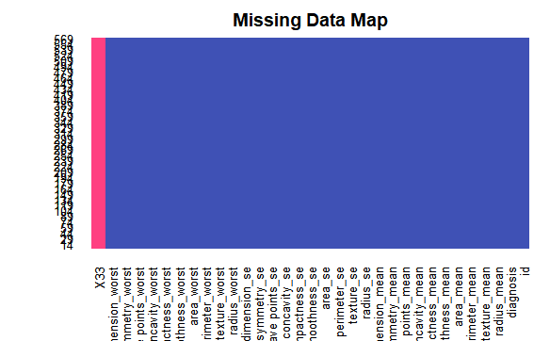

## .. ..- attr(*, "class")= chr "collector_guess" "collector" ## ..- attr(*, "class")= chr "col_spec"

**any**(**is.na**(data))

## [1] TRUE

missmap(CancerData, main="Missing Data Map", col=c("#FF4081", "#3F51B5"), legend=FALSE)

data<-CancerData data[,33]<-NULL

barplot(table(data$diagnosis), xlab = "Type of tumor", ylab="Numbers per type")

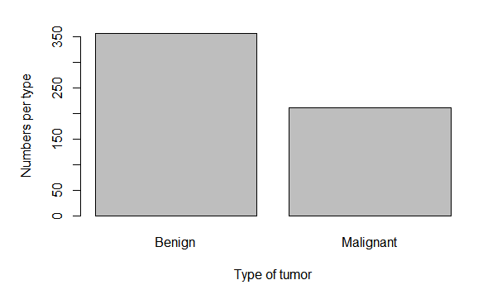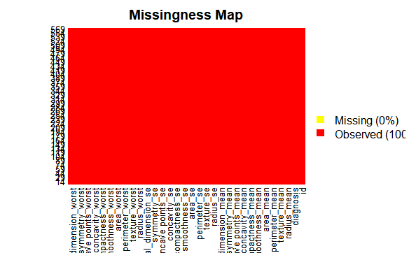

*# visualize the missing values using the missing map from the Amelia package*

**missmap**(data,col=**c**("yellow","red"))

## Warning in if (class(obj) == "amelia") {: the condition has length > 1 and ## only the first element will be used

data**$**diagnosis<-**as.factor**(data**$**diagnosis) data[,33]<-NULL

**summary**(data)

## id diagnosis radius_mean texture_mean ## Min. : 8670 B:357 Min. : 6.981 Min. : 9.71 ## 1st Qu.: 869218 M:212 1st Qu.:11.700 1st Qu.:16.17

## Median : 906024 Median :13.370 Median :18.84

## Mean : 30371831 Mean :14.127 Mean :19.29

## 3rd Qu.: 8813129 3rd Qu.:15.780 3rd Qu.:21.80

## Max. :911320502 Max. :28.110 Max. :39.28

## perimeter_mean area_mean smoothness_mean compactness_mean ## Min. : 43.79 Min. : 143.5 Min. :0.05263 Min. :0.01938 ## 1st Qu.: 75.17 1st Qu.: 420.3 1st Qu.:0.08637 1st Qu.:0.06492

## Median : 86.24 Median : 551.1 Median :0.09587 Median :0.09263

## Mean : 91.97 Mean : 654.9 Mean :0.09636 Mean :0.10434 ## 3rd Qu.:104.10 3rd Qu.: 782.7 3rd Qu.:0.10530 3rd Qu.:0.13040 ## Max. :188.50 Max. :2501.0 Max. :0.16340 Max. :0.34540

## concavity_mean concave points_mean symmetry_mean ## Min. :0.00000 Min. :0.00000 Min. :0.1060 ## 1st Qu.:0.02956 1st Qu.:0.02031 1st Qu.:0.1619

## Median :0.06154 Median :0.03350 Median :0.1792

## Mean :0.08880 Mean :0.04892 Mean :0.1812 ## 3rd Qu.:0.13070 3rd Qu.:0.07400 3rd Qu.:0.1957 ## Max. :0.42680 Max. :0.20120 Max. :0.3040

## fractal_dimension_mean radius_se texture_se perimeter_se ## Min. :0.04996 Min. :0.1115 Min. :0.3602 Min. : 0.757 ## 1st Qu.:0.05770 1st Qu.:0.2324 1st Qu.:0.8339 1st Qu.: 1.606

## Median :0.06154 Median :0.3242 Median :1.1080 Median : 2.287

## Mean :0.06280 Mean :0.4052 Mean :1.2169 Mean : 2.866 ## 3rd Qu.:0.06612 3rd Qu.:0.4789 3rd Qu.:1.4740 3rd Qu.: 3.357 ## Max. :0.09744 Max. :2.8730 Max. :4.8850 Max. :21.980

## area_se smoothness_se compactness_se concavity_se ## Min. : 6.802 Min. :0.001713 Min. :0.002252 Min. :0.00000 ## 1st Qu.: 17.850 1st Qu.:0.005169 1st Qu.:0.013080 1st Qu.:0.01509

## Median : 24.530 Median :0.006380 Median :0.020450 Median :0.02589

## Mean : 40.337 Mean :0.007041 Mean :0.025478 Mean :0.03189 ## 3rd Qu.: 45.190 3rd Qu.:0.008146 3rd Qu.:0.032450 3rd Qu.:0.04205 ## Max. :542.200 Max. :0.031130 Max. :0.135400 Max. :0.39600

## concave points_se symmetry_se fractal_dimension_se ## Min. :0.000000 Min. :0.007882 Min. :0.0008948

## 1st Qu.:0.007638 1st Qu.:0.015160 1st Qu.:0.0022480

## Median :0.010930 Median :0.018730 Median :0.0031870

## Mean :0.011796 Mean :0.020542 Mean :0.0037949 ## 3rd Qu.:0.014710 3rd Qu.:0.023480 3rd Qu.:0.0045580 ## Max. :0.052790 Max. :0.078950 Max. :0.0298400

## radius_worst texture_worst perimeter_worst area_worst ## Min. : 7.93 Min. :12.02 Min. : 50.41 Min. : 185.2 ## 1st Qu.:13.01 1st Qu.:21.08 1st Qu.: 84.11 1st Qu.: 515.3

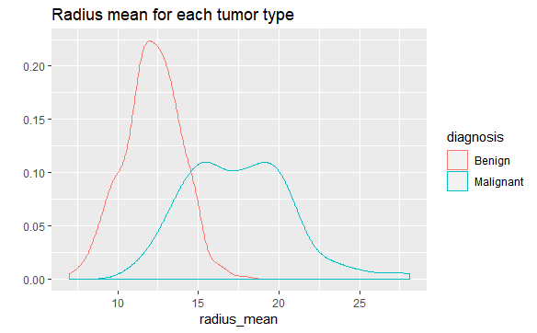

## Median :14.97 Median :25.41 Median : 97.66 Median : 686.5

## Mean :16.27 Mean :25.68 Mean :107.26 Mean : 880.6 ## 3rd Qu.:18.79 3rd Qu.:29.72 3rd Qu.:125.40 3rd Qu.:1084.0 ## Max. :36.04 Max. :49.54 Max. :251.20 Max. :4254.0

## smoothness_worst compactness_worst concavity_worst concave points_worst ## Min. :0.07117 Min. :0.02729 Min. :0.0000 Min. :0.00000

## 1st Qu.:0.11660 1st Qu.:0.14720 1st Qu.:0.1145 1st Qu.:0.06493

## Median :0.13130 Median :0.21190 Median :0.2267 Median :0.09993

## Mean :0.13237 Mean :0.25427 Mean :0.2722 Mean :0.11461 ## 3rd Qu.:0.14600 3rd Qu.:0.33910 3rd Qu.:0.3829 3rd Qu.:0.16140 ## Max. :0.22260 Max. :1.05800 Max. :1.2520 Max. :0.29100

## symmetry_worst fractal_dimension_worst ## Min. :0.1565 Min. :0.05504

## 1st Qu.:0.2504 1st Qu.:0.07146

## Median :0.2822 Median :0.08004

## Mean :0.2901 Mean :0.08395 ## 3rd Qu.:0.3179 3rd Qu.:0.09208 ## Max. :0.6638 Max. :0.20750

qplot(radius_mean, data=data, colour=diagnosis, geom="density", main="Radius mean for each tumor type")

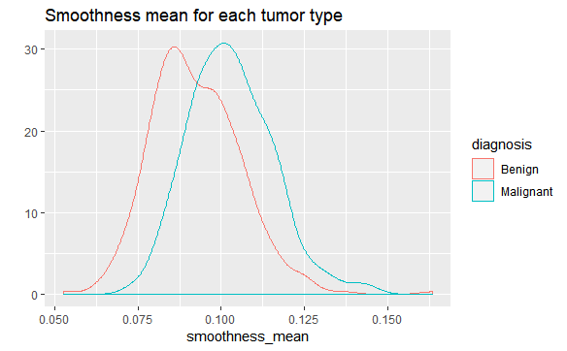

qplot(smoothness_mean, data=data, colour=diagnosis, geom="density",

main="Smoothness mean for each tumor type")

qplot(concavity_mean, data=data, colour=diagnosis, geom="density",

main="Concavity mean for each tumor type")

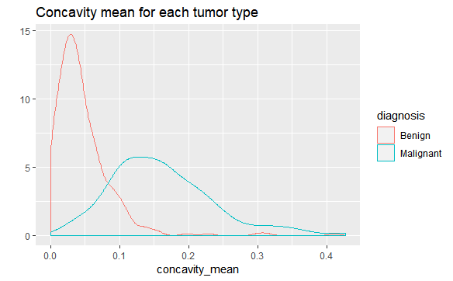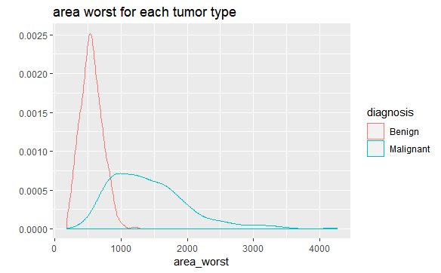

qplot(area_worst , data=data, colour=diagnosis, geom="density", main="area worst for each tumor type")

*# Looking at distribution for area.mean variable*

# plot.new()

**hist**(CancerData**$**area_mean,

main = 'Distribution of Cell Area Means', xlab = 'Mean Area',

col = 'green')

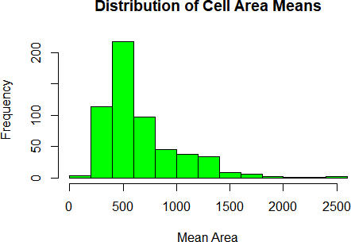

## 0.6274165 0.3725835

## we then show some correlation corr_mat<-**cor**(data[,3**:ncol**(data)]) **corrplot**(corr_mat)

M

B

##

##

*#we find that the data is imbalanced and also there is a lot of corelation*

*between the attributes*

## we find that there are no missing values ## we find that data is little unbalanced **prop.table**(**table**(data**$**diagnosis))

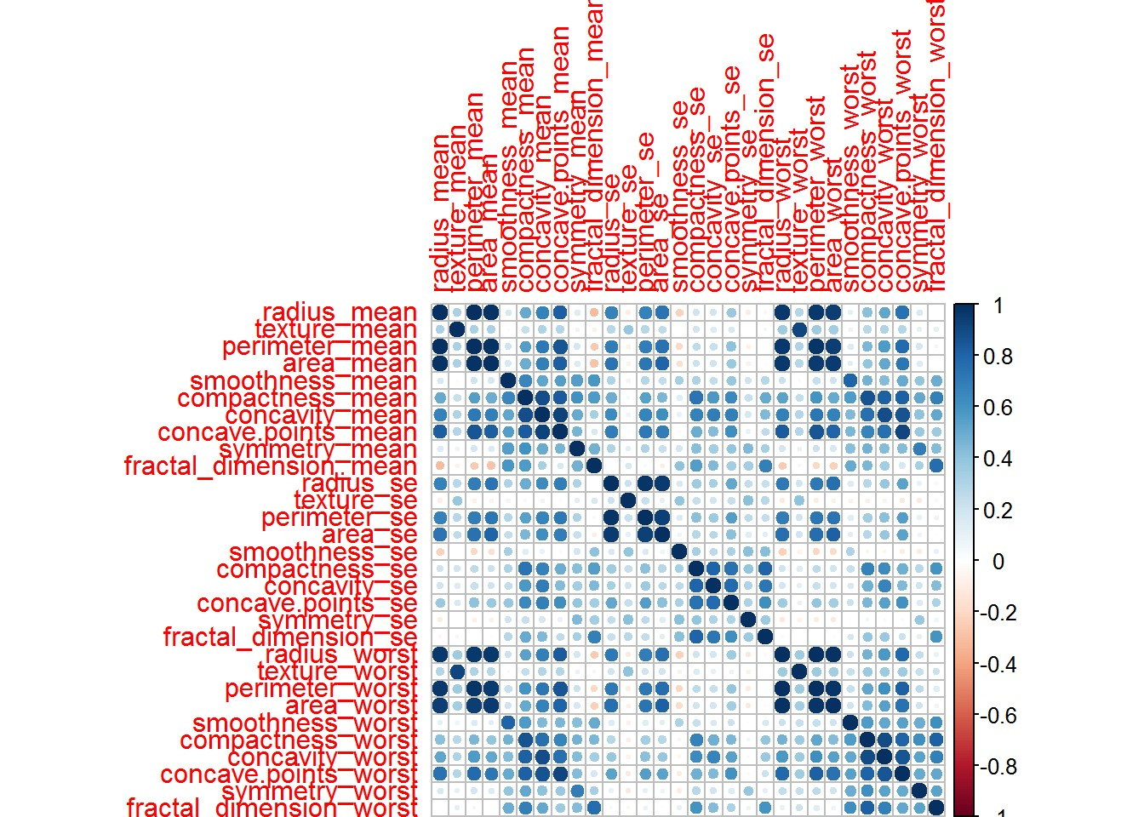

**plot.new**()

**plot**(data**$**area_mean **~**data**$**concavity_mean) **title**('Basic Scatterplot')

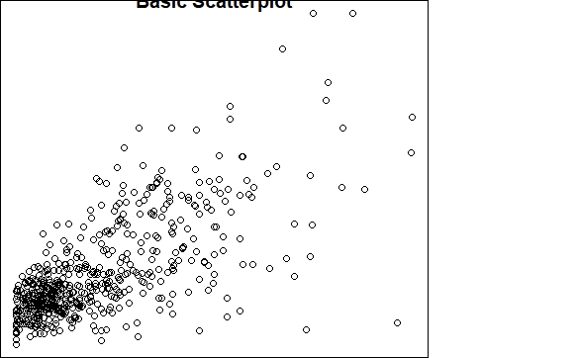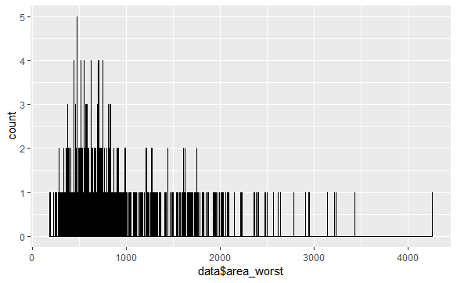

**ggplot**(data, **aes**(x=data**$**area_worst)) **+ geom_histogram**(binwidth = 1, fill = "yellow", color = "black")

**ggplot**(data, **aes**(x=data**$**area_mean)) **+ geom_histogram**(binwidth = 1, fill = "green", color = "red")

*#Modelling*

*#We are going to get a training and a testing set to use when building some models:*

**set.seed**(1234)

data_index<-**createDataPartition**(data**$**diagnosis,p=0.75,list = FALSE) train_data<-data[data_index,**-**1]

test_data<-data[data_index,**-**1]

## Applying learning models

fitControl <- **trainControl**(method="cv",

number = 5,

preProcOptions = **list**(thresh = 0.99), *# threshold*

*for pca preprocess*

*#Model1: Random Forest*

classProbs = TRUE, summaryFunction = twoClassSummary)

*#Building the model on the training data*

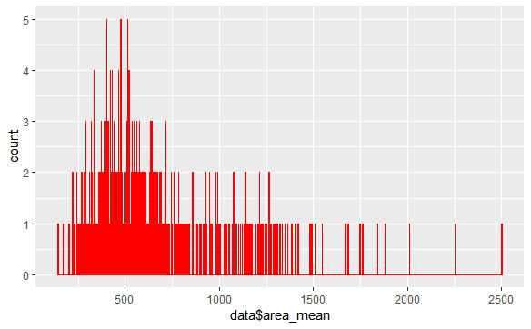

## random forest

model_rf <- **train**(diagnosis**~**.,

train_data, method="ranger", metric="ROC", *#tuneLength=10,*

*#tuneGrid = expand.grid(mtry = c(2, 3, 6)),* preProcess = **c**('center', 'scale'), trControl=fitControl)

*#Testing on the testing data*

## testing for random forets

pred_rf <- **predict**(model_rf, test_data)

cm_rf <- **confusionMatrix**(pred_rf, test_data**$**diagnosis, positive = "M") cm_rf

## Confusion Matrix and Statistics ##

## Reference ## Prediction B M ## B 268 0

## M 0 159 ##

## Accuracy : 1

## 95% CI : (0.9914, 1)

## No Information Rate : 0.6276

## P-Value [Acc > NIR] : < 2.2e-16 ##

## Kappa : 1

## Mcnemar's Test P-Value : NA ##

## Sensitivity : 1.0000

## Specificity : 1.0000

## Pos Pred Value : 1.0000

## Neg Pred Value : 1.0000

## Prevalence : 0.3724

## Detection Rate : 0.3724 ## Detection Prevalence : 0.3724 ## Balanced Accuracy : 1.0000 ##

## 'Positive' Class : M ##

*# We find the accuracy of the model is 100%*

*#Random forest model- takes decision trees and averages them* normalize<-**function**(x){**return**((x**-min**(x))**/**(**max**(x)**-min**(x)))} data**$**diagnosis<-**as.numeric**(data**$**diagnosis)

data_n<-**as.data.frame**(**lapply**(data,normalize)) traindata_n<-**-**data_n[1**:**426,]

testdata_n<-data_n[427**:**569,]

rf <- **randomForest**(diagnosis **~**., data= traindata_n, ntree =300, mtry = 5, importance = TRUE)

## Warning in randomForest.default(m, y, ...): The response has five or fewer ## unique values. Are you sure you want to do regression?

**print**(rf)

##

## Call:

## randomForest(formula = diagnosis ~ ., data = traindata_n, ntree = 300,

mtry = 5, importance = TRUE)

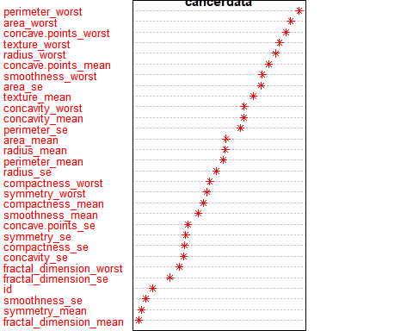

## Type of random forest: regression ## Number of trees: 300

## No. of variables tried at each split: 5 ##

## Mean of squared residuals: 0.03693862 ## % Var explained: 84.79

# plot.new()

**varImpPlot**(rf, type = 1, pch =8, col = 2, cex =0.8, main = "cancerdata")

**abline**(v= 45, col= "red")

**library**(party)

## Loading required package: grid

## Loading required package: mvtnorm

## Loading required package: modeltools

## Loading required package: stats4

## Loading required package: strucchange

## Loading required package: zoo

##

## Attaching package: 'zoo'

## The following objects are masked from 'package:base': ##

## as.Date, as.Date.numeric

## Loading required package: sandwich

*#cf1 <- cforest(diagnosis ~ . , data=traindata_n , control=fitControl(mtry=5,ntree=300)) # fit the random forest*

*#varimp(cf1) # get variable importance, based on mean decrease in accuracy*

*#varimp(cf1, conditional=TRUE) # conditional=True, adjusts for correlations between predictors*

*#varimpAUC(cf1) # more robust towards class imbalance.*

B M MeanDecreaseAccuracy MeanDecreaseGini

|  |  |  |  |
| --- | --- | --- | --- |
| area_worst | 15.13 10.84 | 17.79 | 13.78 |
| concave.points_worst | 13.84 11.08 | 17.58 | 12.86 |
| radius_worst | 13.19 11.08 | 15.99 | 12.32 |
| perimeter_worst | 13.16 10.67 | 15.65 | 14.85 |
| concave.points_mean | 9.53 10.94 | 13.77 | 13.81 |
| concavity_worst | 7.32 9.27 | 11.99 | 3.33 |
| texture_mean | 8.28 9.79 | 11.95 | 2.10 |
| texture_worst | 8.63 10.24 | 11.74 | 2.30 |
| area_se | 8.40 7.98 | 11.33 | 5.83 |
| smoothness_worst | 6.42 8.05 | 10.23 | 1.57 |
| perimeter_mean | 8.58 5.62 | 9.60 | 7.04 |
| radius_mean | 8.55 5.14 | 9.37 | 4.99 |
| area_mean | 8.50 5.28 | 9.30 | 4.07 |
| concavity_mean | 5.31 6.54 | 9.03 | 3.90 |
| perimeter_se | 5.63 6.26 | 8.33 | 1.88 |

|  |  |  |  |
| --- | --- | --- | --- |
| radius_se | 5.66 4.59 | 7.60 | 1.23 |
| smoothness_mean | 4.07 6.30 | 7.34 | 0.92 |
| compactness_mean | 5.84 3.89 | 6.92 | 1.51 |
| compactness_worst | 4.29 4.11 | 6.37 | 1.44 |
| compactness_se | 4.34 2.83 | 5.35 | 0.59 |
| concavity_se | 3.20 3.77 | 5.33 | 0.76 |
| smoothness_se | 3.65 3.47 | 5.30 | 0.58 |
| symmetry_worst | 3.45 4.67 | 5.15 | 1.17 |
| fractal_dimension_worst | 4.31 2.39 | 5.05 | 1.06 |
| texture_se | 3.97 1.92 | 4.44 | 0.55 |
| concave.points_se | 3.70 2.72 | 4.39 | 0.51 |
| symmetry_mean | 0.22 3.69 | 3.03 | 0.45 |
| fractal_dimension_mean | 2.10 1.25 | 2.57 | 0.43 |
| fractal_dimension_se | 1.96 1.34 | 2.56 | 0.64 |
| symmetry_se | 0.96 0.48 | 1.03 | 0.55 |

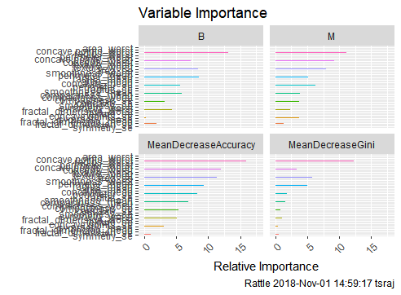

**library**(Boruta)

## Loading required package: ranger

##

## Attaching package: 'ranger'

## The following object is masked from 'package:rattle': ##

## importance

## The following object is masked from 'package:randomForest': ##

## importance

*# Decide if a variable is important or not using Boruta*

boruta_output <- **Boruta**( diagnosis**~** ., data=**na.omit**(train_data), doTrace=2)

*# perform Boruta search*

## 1. run of importance source...

## 2. run of importance source...

## 3. run of importance source...

## 4. run of importance source...

## 5. run of importance source...

## 6. run of importance source...

## 7. run of importance source...

## 8. run of importance source...

## 9. run of importance source...

## 10. run of importance source...

## 11. run of importance source...

## 12. run of importance source...

## After 12 iterations, +3 secs:

## confirmed 23 attributes: `concave points_mean`, `concave points_se`,

`concave points_worst`, area_mean, area_se and 18 more;

## still have 7 attributes left.

|  |  |  |  |  |  |
| --- | --- | --- | --- | --- | --- |
| ## | 13. | run | of | importance | source... |
| ## | 14. | run | of | importance | source... |
| ## | 15. | run | of | importance | source... |
| ## | 16. | run | of | importance | source... |
| ## | 17. | run | of | importance | source... |
| ## | 18. | run | of | importance | source... |
| ## | 19. | run | of | importance | source... |
| ## | 20. | run | of | importance | source... |
| ## | 21. | run | of | importance | source... |
| ## | 22. | run | of | importance | source... |
| ## | 23. | run | of | importance | source... |
| ## | 24. | run | of | importance | source... |
| ## | 25. | run | of | importance | source... |
| ## | 26. | run | of | importance | source... |
| ## | 27. | run | of | importance | source... |
| ## | 28. | run | of | importance | source... |
| ## | 29. | run | of | importance | source... |
| ## | 30. | run | of | importance | source... |

## 31. run of importance source...

## 32. run of importance source...

## 33. run of importance source...

## 34. run of importance source...

## 35. run of importance source...

## After 35 iterations, +8.9 secs:

## confirmed 1 attribute: compactness_se;

## still have 6 attributes left.

## 36. run of importance source...

## 37. run of importance source...

## 38. run of importance source...

## After 38 iterations, +9.7 secs:

## rejected 1 attribute: symmetry_se;

## still have 5 attributes left.

## 39. run of importance source...

## 40. run of importance source...

## 41. run of importance source...

## After 41 iterations, +10 secs:

## confirmed 1 attribute: symmetry_mean;

## rejected 1 attribute: smoothness_se;

## still have 3 attributes left.

## 42. run of importance source...

## 43. run of importance source...

## After 43 iterations, +11 secs:

## confirmed 1 attribute: fractal_dimension_mean;

## still have 2 attributes left.

## 44. run of importance source...

## 45. run of importance source...

|  |  |  |  |  |  |
| --- | --- | --- | --- | --- | --- |
| ## | 46. | run | of | importance | source... |
| ## | 47. | run | of | importance | source... |
| ## | 48. | run | of | importance | source... |
| ## | 49. | run | of | importance | source... |
| ## | 50. | run | of | importance | source... |
| ## | 51. | run | of | importance | source... |
| ## | 52. | run | of | importance | source... |
| ## | 53. | run | of | importance | source... |
| ## | 54. | run | of | importance | source... |
| ## | 55. | run | of | importance | source... |
| ## | 56. | run | of | importance | source... |
| ## | 57. | run | of | importance | source... |
| ## | 58. | run | of | importance | source... |
| ## | 59. | run | of | importance | source... |
| ## | 60. | run | of | importance | source... |
| ## | 61. | run | of | importance | source... |
| ## | 62. | run | of | importance | source... |
| ## | 63. | run | of | importance | source... |
| ## | 64. | run | of | importance | source... |
| ## | 65. | run | of | importance | source... |
| ## | 66. | run | of | importance | source... |
| ## | 67. | run | of | importance | source... |
| ## | 68. | run | of | importance | source... |
| ## | 69. | run | of | importance | source... |
| ## After 69 iterations, +17 secs:  ## confirmed 1 attribute: fractal_dimension_se; ## still have 1 attribute left.  ## 70. run of importance source... | | | | | |

## 71. run of importance source...

## 72. run of importance source...

## 73. run of importance source...

## 74. run of importance source...

## 75. run of importance source...

## 76. run of importance source...

## 77. run of importance source...

## After 77 iterations, +19 secs:

## rejected 1 attribute: texture_se;

## no more attributes left.

boruta_signif <- **names**(boruta_output**$**finalDecision[boruta_output**$**finalDecision **%in% c**("Confirmed", "Tentative")])

boruta_signif

## [1] "radius_mean" "texture_mean"

## [3] "perimeter_mean" "area_mean"

## [5] "smoothness_mean" "compactness_mean"

## [7] "concavity_mean" "`concave points_mean`" ## [9] "symmetry_mean" "fractal_dimension_mean" ## [11] "radius_se" "perimeter_se"

## [13] "area_se" "compactness_se"

## [15] "concavity_se" "`concave points_se`" ## [17] "fractal_dimension_se" "radius_worst"

## [19] "texture_worst" "perimeter_worst"

## [21] "area_worst" "smoothness_worst" ## [23] "compactness_worst" "concavity_worst" ## [25] "`concave points_worst`" "symmetry_worst" ## [27] "fractal_dimension_worst"

*#Model2: Naive Bayes*

*#Building and testing the model*

model_nb <- **train**(diagnosis**~**.,

train_data, method="nb", metric="ROC",

preProcess=**c**('center', 'scale'), trace=FALSE, trControl=fitControl)

cm_nb <- **confusionMatrix**(pred_nb, test_data**$**diagnosis, positive = "M") cm_nb

## Confusion Matrix and Statistics ##

## Reference ## Prediction B M ## B 259 17

## M 9 142 ##

## Accuracy : 0.9391

## 95% CI : (0.9121, 0.9598)

## No Information Rate : 0.6276 ## P-Value [Acc > NIR] : <2e-16 ##

## Kappa : 0.8684

## Mcnemar's Test P-Value : 0.1698 ##

## Sensitivity : 0.8931

## Specificity : 0.9664

## Pos Pred Value : 0.9404

## Neg Pred Value : 0.9384

## Prevalence : 0.3724

## Detection Rate : 0.3326 ## Detection Prevalence : 0.3536 ## Balanced Accuracy : 0.9297 ##

## 'Positive' Class : M ##

*#Accuracy of the model is 93.9% #Model3: glm*

*#Building and testing the model*

model_glm <- **train**(diagnosis**~**.,

train_data, method="glm", metric="ROC",

preProcess=**c**('center', 'scale'), trace=FALSE, trControl=fitControl)

## predicting for test data

pred_glm <- **predict**(model_glm, test_data)

cm_glm <- **confusionMatrix**(pred_glm, test_data**$**diagnosis, positive = "M") cm_glm

## Confusion Matrix and Statistics ##

## Reference ## Prediction B M ## B 265 4

## M 3 155

|  |  |  |  |  |  |  |  |
| --- | --- | --- | --- | --- | --- | --- | --- |
| ## |  | | | | | | |
| ## | Accuracy | : | 0.9836 | |  | | |
| ## | 95% CI | : | (0.9665, | | | 0.9934) |  |
| ## | No Information Rate | : | 0.6276 | |  | | |
| ## | P-Value [Acc > NIR] | : | <2e-16 | |
| ## |  | | | | | | |
| ## | Kappa | : | 0.9649 | |  | | |
| ## | Mcnemar's Test P-Value | : | 1 |  | | | |
| ## |  | | | | | | |
| ## | Sensitivity | : | 0.9748 | |  | | |
| ## | Specificity | : | 0.9888 | |
| ## | Pos Pred Value | : | 0.9810 | |
| ## | Neg Pred Value | : | 0.9851 | |
| ## | Prevalence | : | 0.3724 | |
| ## | Detection Rate | : | 0.3630 | |
| ## | Detection Prevalence | : | 0.3700 | |
| ## | Balanced Accuracy | : | 0.9818 | |
| ## |  | | | | | | |
| ## | 'Positive' Class | : | M |  | | | |
| ## | | | | | | | |
| *#Accuracy of the model is 98.3* | | | | *%* | | | |
| *#algorithm for decision tree* | | | | | | | |
| **library**(C50) | | | | | | | |
| data**$**diagnosis<-**as.factor**(data**$**diagnosis) | | | | | | | |
| tree <- **C5.0**( diagnosis**~**., data = data) | | | | | | | |
| **summary**(tree) | | | | | | | |
| ## | | | | | | | |
| ## Call: | | | | | | | |
| ## C5.0.formula(formula = diagnosis ~ ., data = data) | | | | | | | |
| ## | | | | | | | |
| ## | | | | | | | |
| ## C5.0 [Release 2.07 GPL Edition] Sat Nov 03 17:35:50 2018 | | | | | | | |
| ## ------------------------------- | | | | | | | |
| ## | | | | | | | |
| ## Class specified by attribute `outcome' | | | | | | | |
| ## | | | | | | | |
| ## Read 569 cases (32 attributes) from undefined.data | | | | | | | |
| ## | | | | | | | |
| ## Decision tree: | | | | | | | |
| ## | | | | | | | |
| ## area_worst > 880.8: | | | | | | | |
| ## :...concavity_mean > 0.0716: 2 (164) | | | | | | | |
| ## : concavity_mean <= 0.0716: | | | | | | | |
| ## : :...texture_mean <= 19.54: 1 (9/1) | | | | | | | |
| ## : texture_mean > 19.54: 2 (10) | | | | | | | |
| ## area_worst <= 880.8: | | | | | | | |
| ## :...concave points_worst <= 0.1357: | | | | | | | |
| ## :...area_se <= 36.46: 1 (319/3) | | | | | | | |

## : area_se > 36.46:

## : :...symmetry_worst <= 0.206: 2 (2) ## : symmetry_worst > 0.206: 1 (16/2) ## concave points_worst > 0.1357:

## :...texture_worst > 27.37: 2 (21) ## texture_worst <= 27.37:

## :...concave points_worst > 0.1789: 2 (4) ## concave points_worst <= 0.1789:

## :...area_se <= 21.91: 1 (12)

## area_se > 21.91:

## :...perimeter_se <= 2.615: 2 (6/1)

## perimeter_se > 2.615: 1 (6) ##

##

## Evaluation on training data (569 cases): ##

## Decision Tree ## ----------------

## Size Errors ##

## 11 7( 1.2%) << ##

##

## (a) (b) <-classified as ## ---- ----

## 356 1 (a): class 1

## 6 206 (b): class 2 ##

##

## Attribute usage:

##

## 100.00% area_worst

## 67.84% concave points_worst ## 63.44% area_se

## 32.16% concavity_mean

## 8.61% texture_worst

## 3.34% texture_mean

## 3.16% symmetry_worst

## 2.11% perimeter_se ##

##

## Time: 0.0 secs

# plot.new()

**plot**(tree)

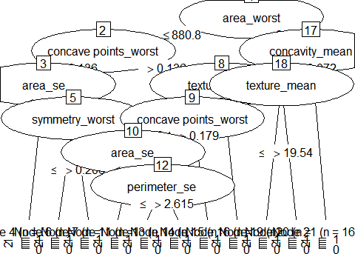

results <- **C5.0**(diagnosis **~**., data = data, rules = TRUE)

**summary**(results)

##

## Call:

## C5.0.formula(formula = diagnosis ~ ., data = data, rules = TRUE) ##

##

## C5.0 [Release 2.07 GPL Edition] Sat Nov 03 17:35:51 2018 ## -------------------------------

##

## Class specified by attribute `outcome' ##

## Read 569 cases (32 attributes) from undefined.data ##

## Rules:

##

## Rule 1: (223/2, lift 1.6)

##

## ## ##

texture_mean <= 19.54

concavity_mean <= 0.0716

->

class 1

[0.987]

## Rule 2: (386/37, lift 1.4)

##

## ##

area_worst <= 880.8

->

class 1

[0.902]

## Rule 3: (164, lift 2.7)

## concavity_mean > 0.0716 ## area_worst > 880.8

## -> class 2 [0.994] ##

## Rule 4: (126, lift 2.7) ## texture_mean > 19.54 ## area_worst > 880.8

## -> class 2 [0.992] ##

## Rule 5: (109, lift 2.7)

## concave points_worst > 0.1789 ## -> class 2 [0.991]

##

## Rule 6: (114, lift 2.7) ## texture_worst > 27.37

## concave points_worst > 0.1357 ## -> class 2 [0.991]

##

## Default class: 1 ##

##

## Evaluation on training data (569 cases): ##

## Rules

## ----------------

## No Errors ##

## 6 13( 2.3%) << ##

##

## (a) (b) <-classified as ## ---- ----

## 357 (a): class 1

## 13 199 (b): class 2 ##

##

## Attribute usage:

##

## 98.42% area_worst

## 68.01% concavity_mean

## 61.34% texture_mean

## 26.89% concave points_worst ## 20.04% texture_worst

## ##

## Time: 0.0 secs

data<-**as.data.frame**(data)

**library**(rpart)

tree<-**rpart**(diagnosis**~**.,data =train_data,method="class")

**plot**(tree) **text**(tree, pretty=0) **library**(rattle) **library**(rpart.plot) **library**(RColorBrewer) **plot.new**()

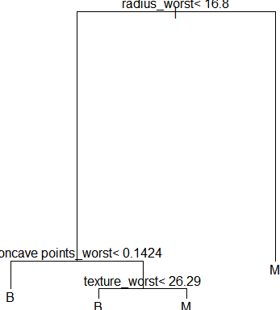

**fancyRpartPlot**(tree) **plot.new**()

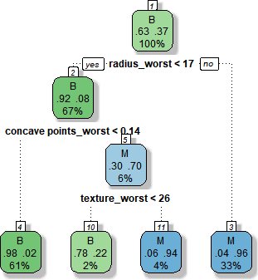

|  |  |  |  |  |  |  |  |
| --- | --- | --- | --- | --- | --- | --- | --- |
| **printcp**(tree)  ##  ## Classification tree:  ## rpart(formula = diagnosis ~ ., data = train_data, method = "class") ##  ## Variables actually used in tree construction:  ## [1] concave points_worst radius_worst texture_worst ##  ## Root node error: 159/427 = 0.37237 ##  ## n= 427  ## | | | | | | |  |
| ## |  | CP | nsplit | rel error | xerror | xstd |  |
| ## | 1 | 0.811321 | 0 | 1.00000 | 1.00000 | 0.062828 |  |
| ## | 2 | 0.069182 | 1 | 0.18868 | 0.26415 | 0.038703 |  |
| ## | 3 | 0.031447 | 2 | 0.11950 | 0.22013 | 0.035651 |  |
| ## | 4 | 0.010000 | 3 | 0.08805 | 0.19497 | 0.033722 |  |
| **plotcp**(tree)  ptree<- **prune**(tree, cp= tree**$**cptable[**which.min**(tree**$**cptable[,"xerror"]),"CP"])  **plot.new**() | | | | | | |  |

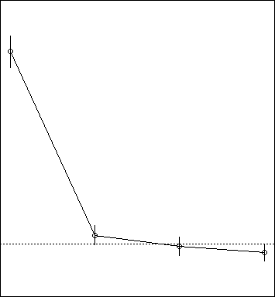

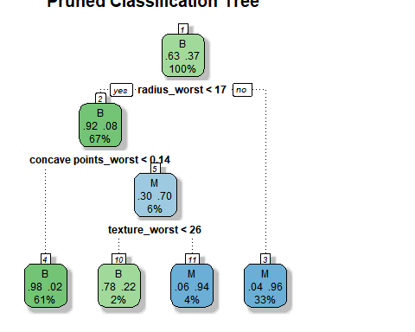

**fancyRpartPlot**(ptree, uniform=TRUE,main="Pruned Classification Tree")

**library**(rpart)

fit1 <- **rpart**(diagnosis**~**.,data=train_data) fit1

## n= 427 ##

## node), split, n, loss, yval, (yprob) ## * denotes terminal node

##

## 1) root 427 159 B (0.62763466 0.37236534)

## 2) radius_worst< 16.795 286 24 B (0.91608392 0.08391608)

## 4) concave points_worst< 0.14235 259 5 B (0.98069498 0.01930502) *

## 5) concave points_worst>=0.14235 27 8 M (0.29629630 0.70370370)

## 10) texture_worst< 26.285 9 2 B (0.77777778 0.22222222) *

## 11) texture_worst>=26.285 18 1 M (0.05555556 0.94444444) *

## 3) radius_worst>=16.795 141 6 M (0.04255319 0.95744681) *

**summary**(fit1)

## Call:

|  |  |  |  |  |
| --- | --- | --- | --- | --- |
|  | | | | |
| nosis ~ ., data = train_data) | | |  | |
|  | | | | |
| rel error | xerror | xstd | |  |
| 1.00000000 | 1.0000000 | 0.06282824 | |
| 0.18867925 | 0.2201258 | 0.03565053 | |
| 0.11949686 | 0.1635220 | 0.03107762 | |
| 0.08805031 | 0.1823899 | 0.03269862 | |
|  | | | | |
| area_worst perimeter_worst | | | | |
| 16 15 | | | | |
| radius_mean perimeter_mean | | | | |
| 14 14 | | | | |
| concavity_worst concavity_mean | | | | |
| 2 1 | | | | |
| concave points_mean compactness_mean | | | | |
| 1 1 | | | | |
|  | | | | |

## rpart(formula = diag

## n= ##

##

427

CP nsplit

## 1 0.81132075 0

## 2 0.06918239 1

## 3 0.03144654 2

## 4 0.01000000 3 ##

## Variable ##

## ## ##

importance radius_worst

16

area_mean

14

## concave points_worst

## 3

## compactness_worst

## ## ## ##

## Node

1

texture_worst

1

number 1: 427 observations, complexity param=0.8113208

## predicted class=B expected loss=0.3723653 P(node) =1 ## class counts: 268 159

## probabilities: 0.628 0.372

## left son=2 (286 obs) right son=3 (141 obs) ## Primary splits:

## radius_worst < 16.795 to the left, improve=144.1264, (0 missing)

## perimeter_worst < 112.6 to the left, improve=143.9985, (0 missing)

|  |  |  |  |  |  |  |  |  |
| --- | --- | --- | --- | --- | --- | --- | --- | --- |
| ##  missing) | area_worst | < | 884.55 | to | the | left, | improve=140.9804, | (0 |
| ## | concave points_worst | < | 0.14235 | to | the | left, | improve=138.8752, | (0 |
| missing) |  |  |  |  |  |  |  |  |
| ## | concave points_mean | < | 0.05593 | to | the | left, | improve=132.0683, | (0 |
| missing) |  |  |  |  |  |  |  |  |
| ## Surrogate splits:  ## area_worst < 868.2 to the left, agree=0.993, adj=0.979, (0 split)  ## perimeter_worst < 111.7 to the left, agree=0.974, adj=0.922, (0 split)  ## area_mean < 697.8 to the left, agree=0.960, adj=0.879, (0 split)  ## radius_mean < 15.045 to the left, agree=0.958, adj=0.872, (0 split)  ## perimeter_mean < 96.405 to the left, agree=0.946, adj=0.837, (0 split)  ##  ## Node number 2: 286 observations, complexity param=0.06918239 ## predicted class=B expected loss=0.08391608 P(node) =0.6697892 ## class counts: 262 24  ## probabilities: 0.916 0.084  ## left son=4 (259 obs) right son=5 (27 obs) ## Primary splits:  ## concave points_worst < 0.14235 to the left, improve=22.90582, (0 missing)  ## concavity_mean < 0.11865 to the left, improve=19.46751, (0 missing)  ## concavity_worst < 0.3782 to the left, improve=19.39395, (0 missing)  ## compactness_worst < 0.3849 to the left, improve=17.79391, (0 missing)  ## concave points_mean < 0.05593 to the left, improve=17.40573, (0 missing)  ## Surrogate splits:  ## concavity_worst < 0.4383 to the left, agree=0.969, adj=0.667, (0 split)  ## compactness_worst < 0.3849 to the left, agree=0.955, adj=0.519, (0 split)  ## concavity_mean < 0.1563 to the left, agree=0.951, adj=0.481, (0 split)  ## concave points_mean < 0.06687 to the left, agree=0.948, adj=0.444, (0 split)  ## compactness_mean < 0.15 to the left, agree=0.937, adj=0.333, (0 split)  ##  ## Node number 3: 141 observations  ## predicted class=M expected loss=0.04255319 P(node) =0.3302108 ## class counts: 6 135  ## probabilities: 0.043 0.957 | | | | | | | | |

##

## Node number 4: 259 observations

## predicted class=B expected loss=0.01930502 P(node) =0.6065574 ## class counts: 254 5

## probabilities: 0.981 0.019 ##

## Node number 5: 27 observations, complexity param=0.03144654 ## predicted class=M expected loss=0.2962963 P(node) =0.06323185 ## class counts: 8 19

## probabilities: 0.296 0.704

## left son=10 (9 obs) right son=11 (18 obs) ## Primary splits:

## texture_worst < 26.285 to the left, improve=6.259259, (0 missing)

## smoothness_worst < 0.1405 to the left, improve=4.680312, (0 missing)

## smoothness_mean < 0.1083 to the left, improve=4.402116, (0 missing)

## texture_mean < 20.3 to the left, improve=3.792593, (0 missing)

## concave points_worst < 0.17175 to the left, improve=3.792593, (0 missing)

## Surrogate splits:

## texture_mean < 16.22 to the left, agree=0.852, adj=0.556, (0 split)

## smoothness_worst < 0.13145 to the left, agree=0.815, adj=0.444, (0 split)

## concavity_mean < 0.089375 to the left, agree=0.778, adj=0.333, (0 split)

## smoothness_se < 0.005373 to the left, agree=0.778, adj=0.333, (0 split)

## concavity_se < 0.11138 to the right, agree=0.778, adj=0.333, (0 split)

##

## Node number 10: 9 observations

## predicted class=B expected loss=0.2222222 P(node) =0.02107728 ## class counts: 7 2

## probabilities: 0.778 0.222 ##

## Node number 11: 18 observations

## predicted class=M expected loss=0.05555556 P(node) =0.04215457 ## class counts: 1 17

## probabilities: 0.056 0.944

*#Kernlab Classification*

**require**(kernlab)

## Loading required package: kernlab

##

## Attaching package: 'kernlab'

## The following object is masked from 'package:modeltools': ##

## prior

## The following object is masked from 'package:ggplot2': ##

## alpha

**installed.packages**("kernlab")

## Package LibPath Version Priority Depends Imports LinkingTo Suggests ## Enhances License License_is_FOSS License_restricts_use OS_type Archs ## MD5sum NeedsCompilation Built

**library**(kernlab)

data_classifier<-**ksvm**(diagnosis **~**., data =train_data , kernel='vanilladot')

## Setting default kernel parameters

data_classifier

## Support Vector Machine object of class "ksvm" ##

## SV type: C-svc (classification) ## parameter : cost C = 1

##

## Linear (vanilla) kernel function. ##

## Number of Support Vectors : 28 ##

## Objective Function Value : -13.7674 ## Training error : 0.007026

data_predictions<-**predict**(data_classifier,test_data)

**head**(data_predictions)

## [1] M M M M M M

## Levels: B M

**table**(data_predictions, test_data**$**diagnosis)

##

## data_predictions B M ## B 267 2

## M 1 157

agreement<-data_predictions **==** test_data**$**diagnosis

**table**(agreement)

|  |  |  |  |  |  |  |  |  |  |  |  |  |
| --- | --- | --- | --- | --- | --- | --- | --- | --- | --- | --- | --- | --- |
| ## agreement  ## FALSE TRUE | | |  | | | | | | | | | |
| ## | 3 | 424 |
| **prop.table**(**tab**  ## agreement | | | **le**(agreement)) | | | | | | | | | |
| ## | FALSE | | TRUE | |  | | | | | | | |
| ## 0.007025761 0.992974239  Agreement | | | | |  | | | | | | | |
| ## | [1] | TRUE | TRUE | TRUE | TRUE | TRUE | TRUE | TRUE | TRUE | TRUE | TRUE | TRUE |
| ## | [12] | TRUE | TRUE | TRUE | TRUE | TRUE | TRUE | TRUE | TRUE | TRUE | TRUE | TRUE |
| ## | [23] | TRUE | TRUE | TRUE | TRUE | TRUE | TRUE | TRUE | TRUE | TRUE | TRUE | TRUE |
| ## | [34] | TRUE | TRUE | TRUE | TRUE | TRUE | TRUE | TRUE | TRUE | TRUE | TRUE | TRUE |
| ## | [45] | TRUE | TRUE | TRUE | TRUE | TRUE | TRUE | TRUE | FALSE | TRUE | TRUE | TRUE |
| ## | [56] | TRUE | TRUE | TRUE | TRUE | TRUE | TRUE | TRUE | TRUE | TRUE | TRUE | TRUE |
| ## | [67] | TRUE | TRUE | TRUE | TRUE | TRUE | TRUE | TRUE | TRUE | TRUE | TRUE | TRUE |
| ## | [78] | TRUE | TRUE | TRUE | TRUE | TRUE | TRUE | TRUE | TRUE | TRUE | TRUE | TRUE |
| ## | [89] | TRUE | TRUE | TRUE | TRUE | TRUE | TRUE | TRUE | TRUE | TRUE | FALSE | TRUE |
| ## | [100] | TRUE | TRUE | TRUE | TRUE | TRUE | TRUE | TRUE | TRUE | TRUE | TRUE | TRUE |
| ## | [111] | TRUE | TRUE | TRUE | TRUE | TRUE | TRUE | TRUE | TRUE | TRUE | TRUE | TRUE |
| ## | [122] | TRUE | TRUE | TRUE | TRUE | TRUE | TRUE | TRUE | TRUE | TRUE | TRUE | TRUE |
| ## | [133] | TRUE | TRUE | TRUE | TRUE | TRUE | TRUE | TRUE | TRUE | TRUE | TRUE | TRUE |
| ## | [144] | TRUE | TRUE | TRUE | TRUE | TRUE | TRUE | TRUE | TRUE | TRUE | TRUE | TRUE |
| ## | [155] | TRUE | TRUE | TRUE | TRUE | TRUE | TRUE | TRUE | TRUE | TRUE | TRUE | TRUE |
| ## | [166] | TRUE | TRUE | TRUE | TRUE | TRUE | TRUE | TRUE | TRUE | TRUE | TRUE | TRUE |
| ## | [177] | FALSE | TRUE | TRUE | TRUE | TRUE | TRUE | TRUE | TRUE | TRUE | TRUE | TRUE |
| ## | [188] | TRUE | TRUE | TRUE | TRUE | TRUE | TRUE | TRUE | TRUE | TRUE | TRUE | TRUE |
| ## | [199] | TRUE | TRUE | TRUE | TRUE | TRUE | TRUE | TRUE | TRUE | TRUE | TRUE | TRUE |
| ## | [210] | TRUE | TRUE | TRUE | TRUE | TRUE | TRUE | TRUE | TRUE | TRUE | TRUE | TRUE |
| ## | [221] | TRUE | TRUE | TRUE | TRUE | TRUE | TRUE | TRUE | TRUE | TRUE | TRUE | TRUE |
| ## | [232] | TRUE | TRUE | TRUE | TRUE | TRUE | TRUE | TRUE | TRUE | TRUE | TRUE | TRUE |
| ## | [243] | TRUE | TRUE | TRUE | TRUE | TRUE | TRUE | TRUE | TRUE | TRUE | TRUE | TRUE |
| ## | [254] | TRUE | TRUE | TRUE | TRUE | TRUE | TRUE | TRUE | TRUE | TRUE | TRUE | TRUE |
| ## | [265] | TRUE | TRUE | TRUE | TRUE | TRUE | TRUE | TRUE | TRUE | TRUE | TRUE | TRUE |
| ## | [276] | TRUE | TRUE | TRUE | TRUE | TRUE | TRUE | TRUE | TRUE | TRUE | TRUE | TRUE |
| ## | [287] | TRUE | TRUE | TRUE | TRUE | TRUE | TRUE | TRUE | TRUE | TRUE | TRUE | TRUE |
| ## | [298] | TRUE | TRUE | TRUE | TRUE | TRUE | TRUE | TRUE | TRUE | TRUE | TRUE | TRUE |
| ## | [309] | TRUE | TRUE | TRUE | TRUE | TRUE | TRUE | TRUE | TRUE | TRUE | TRUE | TRUE |
| ## | [320] | TRUE | TRUE | TRUE | TRUE | TRUE | TRUE | TRUE | TRUE | TRUE | TRUE | TRUE |
| ## | [331] | TRUE | TRUE | TRUE | TRUE | TRUE | TRUE | TRUE | TRUE | TRUE | TRUE | TRUE |
| ## | [342] | TRUE | TRUE | TRUE | TRUE | TRUE | TRUE | TRUE | TRUE | TRUE | TRUE | TRUE |
| ## | [353] | TRUE | TRUE | TRUE | TRUE | TRUE | TRUE | TRUE | TRUE | TRUE | TRUE | TRUE |
| ## | [364] | TRUE | TRUE | TRUE | TRUE | TRUE | TRUE | TRUE | TRUE | TRUE | TRUE | TRUE |
| ## | [375] | TRUE | TRUE | TRUE | TRUE | TRUE | TRUE | TRUE | TRUE | TRUE | TRUE | TRUE |
| ## | [386] | TRUE | TRUE | TRUE | TRUE | TRUE | TRUE | TRUE | TRUE | TRUE | TRUE | TRUE |
| ## | [397] | TRUE | TRUE | TRUE | TRUE | TRUE | TRUE | TRUE | TRUE | TRUE | TRUE | TRUE |

|  |  |  |  |  |  |  |  |  |  |  |  |  |  |
| --- | --- | --- | --- | --- | --- | --- | --- | --- | --- | --- | --- | --- | --- |
| ## [408] | | TRUE TRUE | TRUE | TRUE | TRUE | TRUE | TRUE | | TRUE | TRUE | TRUE | TRUE | |
| ## [419] | | TRUE TRUE | TRUE | TRUE | TRUE | TRUE | TRUE | | TRUE | TRUE |  |  | |
| **set.seed**(12345) data_classifier_rbf<- data_predictions_rbf< agreement_rbf<-data_p **table**(agreement_rbf)  ## agreement_rbf ## FALSE TRUE ## 2 425  **prop.table**(**table**(agre ## agreement_rbf  ## FALSE  ## 0.004683841 0.9953  *# logistic regression*  fit <- **glm**(diagnosis**~** ## Warning: glm.fit: **summary**(fit)  ##  ## Call:  ## glm(formula = diag ## data = train_d ##  ## Deviance Residuals ## Min 1Q Me ## -8.49 0.00  ## | | | **ksvm**(  -**pred** redic  ement  TRUE 16159  *mode*  .,dat fitte  nosis ata)  :  dian 0.00 | diagnosis **~**., data = train_data, kernel='rbfdot')  **ict**(data_classifier_rbf,test_data) tions_rbf **==** test_data**$**diagnosis  _rbf))  *l:*  a = train_data,family = **binomial**(link='logit')) d probabilities numerically 0 or 1 occurred  ~ ., family = binomial(link = "logit"),  3Q Max  0.00 8.49 | | | | | | | | | |
| ##  ## | Coefficients: | | | Estimate | | Std. Error | | z value | | Pr(>|z|) | |  |  |
| ## | (Intercept) | | | -5.487e+15 | | 1.418e+08 | | -38703923 | | <2e-16 | | *** |  |
| ## | radius_mean | | | -1.401e+13 | | 5.949e+07 | | -235423 | | <2e-16 | | *** |  |
| ## | texture_mean | | | -5.783e+13 | | 2.594e+06 | | -22293459 | | <2e-16 | | *** |  |
| ## | perimeter_mean | | | -1.954e+14 | | 8.518e+06 | | -22935779 | | <2e-16 | | *** |  |
| ## | area_mean | | | 7.231e+12 | | 1.723e+05 | | 41962794 | | <2e-16 | | *** |  |
| ## | smoothness_mean | | | 1.141e+16 | | 6.970e+08 | | 16374586 | | <2e-16 | | *** |  |
| ## | compactness_mean | | | -1.560e+16 | | 4.601e+08 | | -33898361 | | <2e-16 | | *** |  |
| ## | concavity_mean | | | 3.612e+15 | | 3.663e+08 | | 9859481 | | <2e-16 | | *** |  |
| ## | `concave points_mean` | | | 3.368e+16 | | 6.496e+08 | | 51839897 | | <2e-16 | | *** |  |
| ## | symmetry_mean | | | 7.166e+14 | | 2.485e+08 | | 2883416 | | <2e-16 | | *** |  |
| ## | fractal_dimension_mean | | | -1.875e+16 | | 1.853e+09 | | -10119625 | | <2e-16 | | *** |  |
| ## | radius_se | | | -1.780e+14 | | 1.147e+08 | | -1552350 | | <2e-16 | | *** |  |
| ## | texture_se | | | -5.141e+14 | | 1.143e+07 | | -44982769 | | <2e-16 | | *** |  |
| ## | perimeter_se | | | -1.506e+14 | | 1.516e+07 | | -9929607 | | <2e-16 | | *** |  |
| ## | area_se | | | 3.909e+12 | | 4.713e+05 | | 8294154 | | <2e-16 | | *** |  |

|  |  |  |  |  |  |  |  |  |  |
| --- | --- | --- | --- | --- | --- | --- | --- | --- | --- |
| ## | smoothness_se | 6.741e+16 | | 2.230e+09 | | 30224242 | <2e-16 | *** |  |
| ## | compactness_se | -1.263e+16 | | 7.957e+08 | | -15868906 | <2e-16 | *** |
| ## | concavity_se | -6.112e+15 | | 4.465e+08 | | -13688233 | <2e-16 | *** |
| ## | `concave points_se` | 2.479e+16 | | 1.882e+09 | | 13170418 | <2e-16 | *** |
| ## | symmetry_se | 3.309e+16 | | 8.953e+08 | | 36963236 | <2e-16 | *** |
| ## | fractal_dimension_se | 2.482e+16 | | 4.032e+09 | | 6155984 | <2e-16 | *** |
| ## | radius_worst | 7.751e+14 | | 2.067e+07 | | 37495454 | <2e-16 | *** |
| ## | texture_worst | 1.151e+14 | | 2.192e+06 | | 52500738 | <2e-16 | *** |
| ## | perimeter_worst | 7.806e+13 | | 2.049e+06 | | 38088467 | <2e-16 | *** |
| ## | area_worst | -5.352e+12 | | 1.108e+05 | | -48313624 | <2e-16 | *** |
| ## | smoothness_worst | -4.364e+15 | | 4.930e+08 | | -8850467 | <2e-16 | *** |
| ## | compactness_worst | 1.527e+15 | | 1.306e+08 | | 11684310 | <2e-16 | *** |
| ## | concavity_worst | 2.629e+15 | | 9.403e+07 | | 27964084 | <2e-16 | *** |
| ## | `concave points_worst` | -5.585e+15 | | 3.231e+08 | | -17282850 | <2e-16 | *** |
| ## | symmetry_worst | -1.380e+15 | | 1.615e+08 | | -8543749 | <2e-16 | *** |
| ## | fractal_dimension_worst | 8.968e+15 | | 7.758e+08 | | 11560246 | <2e-16 | *** |
| ## | --- |  | |  | |  |  |  |
| ## Signif. codes: 0 '***' 0.001 '**' 0.01 '*' 0.05 '.' 0.1 ' ' 1 ##  ## (Dispersion parameter for binomial family taken to be 1) ##  ## Null deviance: 563.81 on 426 degrees of freedom ## Residual deviance: 504.61 on 396 degrees of freedom ## AIC: 566.61  ##  ## Number of Fisher Scoring iterations: 19  **library**(MASS)  step_fit <- **stepAIC**(fit,method='backward')  ## Start: AIC=566.61  ## diagnosis ~ radius_mean + texture_mean + perimeter_mean + area_mean ## smoothness_mean + compactness_mean + concavity_mean + `concave points_mean` +  ## symmetry_mean + fractal_dimension_mean + radius_se + texture_se ## perimeter_se + area_se + smoothness_se + compactness_se +  ## concavity_se + `concave points_se` + symmetry_se + fractal_dimension_se +  ## radius_worst + texture_worst + perimeter_worst + area_worst + ## smoothness_worst + compactness_worst + concavity_worst +  ## `concave points_worst` + symmetry_worst + fractal_dimension_wors | | | | | | | | | +  +  t |
| ## |  | Df | Deviance | | AIC | | | | |
| ## | - perimeter_se | 1 | 0.00 | | 60.00 | | | | |
| ## | - area_mean | 1 | 0.00 | | 60.00 | | | | |
| ## | - radius_mean | 1 | 0.00 | | 60.00 | | | | |
| ## | - area_se | 1 | 0.00 | | 60.00 | | | | |
| ## | - symmetry_se | 1 | 0.00 | | 60.00 | | | | |
| ## | - radius_worst | 1 | 0.00 | | 60.00 | | | | |
| ## | - radius_se | 1 | 0.00 | | 60.00 | | | | |

|  |  |  |  |  |  |
| --- | --- | --- | --- | --- | --- |
| ## | - texture_mean | 1 | 0.00 | 60.00 | |
| ## | - smoothness_worst | 1 | 0.00 | 60.00 | |
| ## | - compactness_mean | 1 | 0.00 | 60.00 | |
| ## | - area_worst | 1 | 0.00 | 60.00 | |
| ## | - smoothness_mean | 1 | 0.00 | 60.00 | |
| ## | - compactness_se | 1 | 0.00 | 60.00 | |
| ## | - `concave points_se` | 1 | 0.00 | 60.00 | |
| ## | - perimeter_worst | 1 | 0.00 | 60.00 | |
| ## | - compactness_worst | 1 | 0.00 | 60.00 | |
| ## | - concavity_se | 1 | 0.00 | 60.00 | |
| ## | - `concave points_mean` | 1 | 0.00 | 60.00 | |
| ## | - smoothness_se | 1 | 0.00 | 60.00 | |
| ## | - symmetry_mean | 1 | 0.00 | 60.00 | |
| ## | - `concave points_worst` | 1 | 0.00 | 60.00 | |
| ## | - symmetry_worst | 1 | 0.00 | 60.00 | |
| ## | - fractal_dimension_mean | 1 | 0.00 | 60.00 | |
| ## | - fractal_dimension_se | 1 | 0.00 | 60.00 | |
| ## | - texture_se | 1 | 0.00 | 60.00 | |
| ## | - perimeter_mean | 1 | 0.00 | 60.00 | |
| ## | - fractal_dimension_worst | 1 | 0.00 | 60.00 | |
| ## | - texture_worst | 1 | 0.00 | 60.00 | |
| ## | - concavity_mean | 1 | 0.00 | 60.00 | |
| ## | - concavity_worst | 1 | 0.00 | 60.00 | |
| ## | <none> |  | 504.61 | 566.61 | |
| ## Warning: glm.fit: algorithm did not converge  ## Warning: glm.fit: fitted probabilities numerically 0 or 1 occurred ##  ## Step: AIC=60  ## diagnosis ~ radius_mean + texture_mean + perimeter_mean + area_mean + ## smoothness_mean + compactness_mean + concavity_mean + `concave points_mean` +  ## symmetry_mean + fractal_dimension_mean + radius_se + texture_se + ## area_se + smoothness_se + compactness_se + concavity_se +  ## `concave points_se` + symmetry_se + fractal_dimension_se + ## radius_worst + texture_worst + perimeter_worst + area_worst + ## smoothness_worst + compactness_worst + concavity_worst +  ## `concave points_worst` + symmetry_worst + fractal_dimension_worst | | | | | |
| ## |  | Df | Deviance | | AIC |
| ## | - symmetry_worst | 1 | 8.1185e-08 | | 58 |
| ## | - smoothness_mean | 1 | 8.1328e-08 | | 58 |
| ## | - radius_mean | 1 | 8.1330e-08 | | 58 |
| ## | - symmetry_se | 1 | 8.1384e-08 | | 58 |
| ## | - perimeter_mean | 1 | 8.1412e-08 | | 58 |
| ## | - concavity_mean | 1 | 8.1488e-08 | | 58 |
| ## | - fractal_dimension_mean | 1 | 8.1635e-08 | | 58 |
| ## | - concavity_worst | 1 | 8.1665e-08 | | 58 |

|  |  |  |  |  |
| --- | --- | --- | --- | --- |
| ## | - area_se | 1 | 8.1827e-08 | 58 |
| ## | - area_mean | 1 | 8.1867e-08 | 58 |
| ## | - smoothness_worst | 1 | 8.2830e-08 | 58 |
| ## | - radius_worst | 1 | 8.2832e-08 | 58 |
| ## | - texture_mean | 1 | 8.3132e-08 | 58 |
| ## | - area_worst | 1 | 8.3541e-08 | 58 |
| ## | - radius_se | 1 | 8.3657e-08 | 58 |
| ## | - texture_se | 1 | 8.4696e-08 | 58 |
| ## | - compactness_se | 1 | 8.4708e-08 | 58 |
| ## | - `concave points_se` | 1 | 8.4934e-08 | 58 |
| ## | - `concave points_worst` | 1 | 8.5490e-08 | 58 |
| ## | - symmetry_mean | 1 | 8.6407e-08 | 58 |
| ## | - compactness_worst | 1 | 8.6824e-08 | 58 |
| ## | - smoothness_se | 1 | 8.7001e-08 | 58 |
| ## | - concavity_se | 1 | 8.7224e-08 | 58 |
| ## | - compactness_mean | 1 | 8.9111e-08 | 58 |
| ## | - perimeter_worst | 1 | 9.3748e-08 | 58 |
| ## | - `concave points_mean` | 1 | 9.7167e-08 | 58 |
| ## | - fractal_dimension_se | 1 | 1.0211e-07 | 58 |
| ## | - texture_worst | 1 | 1.2312e-07 | 58 |
| ## | - fractal_dimension_worst | 1 | 1.2498e-07 | 58 |
| ## | <none> |  | 8.1046e-08 | 60 |
| ## ## | Step: AIC=58 |  |  |  |
| ## diagnosis ~ radius_mean + texture_mean + perimeter_mean + area_mean +  ## smoothness_mean + compactness_mean + concavity_mean + `concave points_mean` +  ## symmetry_mean + fractal_dimension_mean + radius_se + texture_se + ## area_se + smoothness_se + compactness_se + concavity_se +  ## `concave points_se` + symmetry_se + fractal_dimension_se + ## radius_worst + texture_worst + perimeter_worst + area_worst + ## smoothness_worst + compactness_worst + concavity_worst +  ## `concave points_worst` + fractal_dimension_worst | | | | |
| ## |  | Df | Deviance | AIC |
| ## | - smoothness_mean | 1 | 8.1503e-08 | 56 |
| ## | - concavity_mean | 1 | 8.1710e-08 | 56 |
| ## | - area_mean | 1 | 8.1904e-08 | 56 |
| ## | - concavity_worst | 1 | 8.1932e-08 | 56 |
| ## | - area_se | 1 | 8.1989e-08 | 56 |
| ## | - radius_mean | 1 | 8.2183e-08 | 56 |
| ## | - perimeter_mean | 1 | 8.2263e-08 | 56 |
| ## | - symmetry_se | 1 | 8.2539e-08 | 56 |
| ## | - fractal_dimension_mean | 1 | 8.2652e-08 | 56 |
| ## | - radius_worst | 1 | 8.3116e-08 | 56 |
| ## | - texture_mean | 1 | 8.3594e-08 | 56 |
| ## | - area_worst | 1 | 8.3792e-08 | 56 |
| ## | - radius_se | 1 | 8.4234e-08 | 56 |
| ## | - smoothness_worst | 1 | 8.4388e-08 | 56 |

|  |  |  |  |  |
| --- | --- | --- | --- | --- |
| ## | - texture_se | 1 | 8.5299e-08 | 56 |
| ## | - compactness_se | 1 | 8.5309e-08 | 56 |
| ## | - `concave points_se` | 1 | 8.6048e-08 | 56 |
| ## | - concavity_se | 1 | 8.7340e-08 | 56 |
| ## | - `concave points_worst` | 1 | 8.7440e-08 | 56 |
| ## | - compactness_worst | 1 | 8.7947e-08 | 56 |
| ## | - symmetry_mean | 1 | 8.9378e-08 | 56 |
| ## | - smoothness_se | 1 | 9.0366e-08 | 56 |
| ## | - compactness_mean | 1 | 9.0526e-08 | 56 |
| ## | - perimeter_worst | 1 | 1.0307e-07 | 56 |
| ## | - fractal_dimension_se | 1 | 1.0347e-07 | 56 |
| ## | - `concave points_mean` | 1 | 1.0610e-07 | 56 |
| ## | - fractal_dimension_worst | 1 | 1.1613e-07 | 56 |
| ## | - texture_worst | 1 | 1.3057e-07 | 56 |
| ## | <none> |  | 8.1185e-08 | 58 |
| ## ## | Step: AIC=56 |  |  |  |
| ## diagnosis ~ radius_mean + texture_mean + perimeter_mean + area_mean +  ## compactness_mean + concavity_mean + `concave points_mean` +  ## symmetry_mean + fractal_dimension_mean + radius_se + texture_se + ## area_se + smoothness_se + compactness_se + concavity_se +  ## `concave points_se` + symmetry_se + fractal_dimension_se + ## radius_worst + texture_worst + perimeter_worst + area_worst + ## smoothness_worst + compactness_worst + concavity_worst +  ## `concave points_worst` + fractal_dimension_worst | | | | |
| ## |  | Df | Deviance | AIC |
| ## | - concavity_worst | 1 | 8.2241e-08 | 54 |
| ## | - concavity_mean | 1 | 8.2344e-08 | 54 |
| ## | - perimeter_mean | 1 | 8.2473e-08 | 54 |
| ## | - radius_mean | 1 | 8.2570e-08 | 54 |
| ## | - symmetry_se | 1 | 8.2688e-08 | 54 |
| ## | - area_mean | 1 | 8.3433e-08 | 54 |
| ## | - fractal_dimension_mean | 1 | 8.3635e-08 | 54 |
| ## | - area_se | 1 | 8.3636e-08 | 54 |
| ## | - radius_worst | 1 | 8.3745e-08 | 54 |
| ## | - area_worst | 1 | 8.4731e-08 | 54 |
| ## | - compactness_se | 1 | 8.5398e-08 | 54 |
| ## | - texture_mean | 1 | 8.5575e-08 | 54 |
| ## | - radius_se | 1 | 8.5625e-08 | 54 |
| ## | - texture_se | 1 | 8.5921e-08 | 54 |
| ## | - `concave points_se` | 1 | 8.7731e-08 | 54 |
| ## | - smoothness_worst | 1 | 8.7924e-08 | 54 |
| ## | - compactness_worst | 1 | 8.7985e-08 | 54 |
| ## | - symmetry_mean | 1 | 9.0013e-08 | 54 |
| ## | - concavity_se | 1 | 9.0401e-08 | 54 |
| ## | - compactness_mean | 1 | 9.1017e-08 | 54 |
| ## | - smoothness_se | 1 | 9.1332e-08 | 54 |
| ## | - `concave points_worst` | 1 | 9.1496e-08 | 54 |

## - fractal_dimension_se 1 1.0358e-07 54

## - perimeter_worst 1 1.0853e-07 54 ## - `concave points_mean` 1 1.1045e-07 54 ## - fractal_dimension_worst 1 1.1273e-07 54

## - texture_worst 1 1.3219e-07 54 ## <none> 8.1503e-08 56

##

## Step: AIC=54

## diagnosis ~ radius_mean + texture_mean + perimeter_mean + area_mean + ## compactness_mean + concavity_mean + `concave points_mean` +

## symmetry_mean + fractal_dimension_mean + radius_se + texture_se + ## area_se + smoothness_se + compactness_se + concavity_se +

## `concave points_se` + symmetry_se + fractal_dimension_se + ## radius_worst + texture_worst + perimeter_worst + area_worst +

## smoothness_worst + compactness_worst + `concave points_worst` + ## fractal_dimension_worst

rimeter_mean + area_mean +

|  |  |  |  |  |
| --- | --- | --- | --- | --- |
| ## |  | Df | Deviance | AIC |
| ## | - symmetry_se | 1 | 8.3042e-08 | 52 |
| ## | - radius_worst | 1 | 8.3582e-08 | 52 |
| ## | - perimeter_mean | 1 | 8.3733e-08 | 52 |
| ## | - radius_mean | 1 | 8.4489e-08 | 52 |
| ## | - compactness_se | 1 | 8.5639e-08 | 52 |
| ## | - area_se | 1 | 8.5749e-08 | 52 |
| ## | - area_worst | 1 | 8.6048e-08 | 52 |
| ## | - texture_mean | 1 | 8.6272e-08 | 52 |
| ## | - fractal_dimension_mean | 1 | 8.6830e-08 | 52 |
| ## | - radius_se | 1 | 8.7124e-08 | 52 |
| ## | - `concave points_se` | 1 | 8.7824e-08 | 52 |
| ## | - compactness_worst | 1 | 8.7956e-08 | 52 |
| ## | - texture_se | 1 | 8.8696e-08 | 52 |
| ## | - smoothness_worst | 1 | 8.9126e-08 | 52 |
| ## | - concavity_mean | 1 | 8.9451e-08 | 52 |
| ## | - smoothness_se | 1 | 9.1712e-08 | 52 |
| ## | - compactness_mean | 1 | 9.1994e-08 | 52 |
| ## | - area_mean | 1 | 9.2627e-08 | 52 |
| ## | - `concave points_worst` | 1 | 9.2804e-08 | 52 |
| ## | - concavity_se | 1 | 9.6123e-08 | 52 |
| ## | - symmetry_mean | 1 | 9.7910e-08 | 52 |
| ## | - fractal_dimension_se | 1 | 1.0849e-07 | 52 |
| ## | - `concave points_mean` | 1 | 1.0954e-07 | 52 |
| ## | - fractal_dimension_worst | 1 | 1.1344e-07 | 52 |
| ## | - perimeter_worst | 1 | 1.2244e-07 | 52 |
| ## | - texture_worst | 1 | 1.6824e-07 | 52 |
| ##  ## ## | <none>  Step: AIC=52  diagnosis ~ radius_mean + | 8.2241e-08 54  texture_mean + pe | | |

##

## ## ## ## ##

compactness_mean + concavity_mean + `concave points_mean` +

symmetry_mean + fractal_dimension_mean + radius_se + texture_se + area_se + smoothness_se + compactness_se + concavity_se +

`concave points_se` + fractal_dimension_se + radius_worst + texture_worst + perimeter_worst + area_worst + smoothness_worst + compactness_worst + `concave points_worst` + fractal_dimension_worst

|  |  |  |  |  |
| --- | --- | --- | --- | --- |
| ## |  | Df | Deviance | AIC |
| ## | - radius_worst | 1 | 8.3575e-08 | 50 |
| ## | - area_se | 1 | 8.5568e-08 | 50 |
| ## | - compactness_se | 1 | 8.5576e-08 | 50 |
| ## | - perimeter_mean | 1 | 8.6771e-08 | 50 |
| ## | - texture_mean | 1 | 8.6950e-08 | 50 |
| ## | - radius_se | 1 | 8.7007e-08 | 50 |
| ## | - radius_mean | 1 | 8.7320e-08 | 50 |
| ## | - `concave points_se` | 1 | 8.7396e-08 | 50 |
| ## | - area_worst | 1 | 8.7536e-08 | 50 |
| ## | - smoothness_worst | 1 | 8.8966e-08 | 50 |
| ## | - area_mean | 1 | 9.2306e-08 | 50 |
| ## | - texture_se | 1 | 9.2709e-08 | 50 |
| ## | - `concave points_worst` | 1 | 9.2936e-08 | 50 |
| ## | - compactness_worst | 1 | 9.2986e-08 | 50 |
| ## | - fractal_dimension_mean | 1 | 9.4960e-08 | 50 |
| ## | - concavity_mean | 1 | 9.7411e-08 | 50 |
| ## | - smoothness_se | 1 | 9.7640e-08 | 50 |
| ## | - concavity_se | 1 | 9.8434e-08 | 50 |
| ## | - compactness_mean | 1 | 1.0148e-07 | 50 |
| ## | - fractal_dimension_worst | 1 | 1.2325e-07 | 50 |
| ## | - `concave points_mean` | 1 | 1.2837e-07 | 50 |
| ## | - perimeter_worst | 1 | 1.2904e-07 | 50 |
| ## | - fractal_dimension_se | 1 | 1.3028e-07 | 50 |
| ## | - symmetry_mean | 1 | 1.4516e-07 | 50 |
| ## | - texture_worst | 1 | 1.7117e-07 | 50 |
| ## | <none> |  | 8.3042e-08 | 52 |
| ## ## | Step: AIC=50 |  |  |  |
| ## diagnosis ~ radius_mean + texture_mean + perimeter_mean + area_mean + ## compactness_mean + concavity_mean + `concave points_mean` +  ## symmetry_mean + fractal_dimension_mean + radius_se + texture_se + ## area_se + smoothness_se + compactness_se + concavity_se +  ## `concave points_se` + fractal_dimension_se + texture_worst +  ## perimeter_worst + area_worst + smoothness_worst + compactness_worst + ## `concave points_worst` + fractal_dimension_worst | | | | |
| ## |  | Df | Deviance | AIC |
| ## | - compactness_se | 1 | 8.5992e-08 | 48 |
| ## | - area_se | 1 | 8.6162e-08 | 48 |
| ## | - texture_mean | 1 | 8.7211e-08 | 48 |
| ## | - radius_se | 1 | 8.7920e-08 | 48 |

|  |  |  |  |  |
| --- | --- | --- | --- | --- |
| ## | - `concave points_se` | 1 | 8.8100e-08 | 48 |
| ## | - smoothness_worst | 1 | 9.0500e-08 | 48 |
| ## | - area_worst | 1 | 9.1877e-08 | 48 |
| ## | - `concave points_worst` | 1 | 9.3927e-08 | 48 |
| ## | - area_mean | 1 | 9.5348e-08 | 48 |
| ## | - fractal_dimension_mean | 1 | 9.5713e-08 | 48 |
| ## | - texture_se | 1 | 9.7257e-08 | 48 |
| ## | - concavity_mean | 1 | 9.9576e-08 | 48 |
| ## | - compactness_worst | 1 | 1.0035e-07 | 48 |
| ## | - concavity_se | 1 | 1.0195e-07 | 48 |
| ## | - perimeter_mean | 1 | 1.0323e-07 | 48 |
| ## | - compactness_mean | 1 | 1.0358e-07 | 48 |
| ## | - smoothness_se | 1 | 1.0375e-07 | 48 |
| ## | - radius_mean | 1 | 1.0978e-07 | 48 |
| ## | - fractal_dimension_se | 1 | 1.3788e-07 | 48 |
| ## | - `concave points_mean` | 1 | 1.4162e-07 | 48 |
| ## | - perimeter_worst | 1 | 1.5232e-07 | 48 |
| ## | - symmetry_mean | 1 | 1.6084e-07 | 48 |
| ## | - fractal_dimension_worst | 1 | 1.6307e-07 | 48 |
| ## | - texture_worst | 1 | 1.7361e-07 | 48 |
| ## | <none> |  | 8.3575e-08 | 50 |
| ## ## | Step: AIC=48 |  |  |  |
| ## diagnosis ~ radius_mean + texture_mean + perimeter_mean + area_mean +  ## compactness_mean + concavity_mean + `concave points_mean` +  ## symmetry_mean + fractal_dimension_mean + radius_se + texture_se + ## area_se + smoothness_se + concavity_se + `concave points_se` + ## fractal_dimension_se + texture_worst + perimeter_worst +  ## area_worst + smoothness_worst + compactness_worst + `concave points_worst` +  ## fractal_dimension_worst | | | | |
| ## |  | Df | Deviance | AIC |
| ## | - area_se | 1 | 8.6642e-08 | 46 |
| ## | - radius_se | 1 | 8.7847e-08 | 46 |
| ## | - texture_mean | 1 | 8.7903e-08 | 46 |
| ## | - `concave points_se` | 1 | 9.0391e-08 | 46 |
| ## | - smoothness_worst | 1 | 9.2366e-08 | 46 |
| ## | - area_worst | 1 | 9.4740e-08 | 46 |
| ## | - fractal_dimension_mean | 1 | 9.4814e-08 | 46 |
| ## | - `concave points_worst` | 1 | 9.6245e-08 | 46 |
| ## | - area_mean | 1 | 9.7249e-08 | 46 |
| ## | - texture_se | 1 | 9.8732e-08 | 46 |
| ## | - concavity_mean | 1 | 1.0099e-07 | 46 |
| ## | - concavity_se | 1 | 1.0248e-07 | 46 |
| ## | - compactness_mean | 1 | 1.0308e-07 | 46 |
| ## | - smoothness_se | 1 | 1.0409e-07 | 46 |
| ## | - compactness_worst | 1 | 1.1529e-07 | 46 |
| ## | - perimeter_mean | 1 | 1.1614e-07 | 46 |

|  |  |  |  |  |
| --- | --- | --- | --- | --- |
| ## | - radius_mean | 1 | 1.2106e-07 | 46 |
| ## | - perimeter_worst | 1 | 1.5568e-07 | 46 |
| ## | - `concave points_mean` | 1 | 1.5706e-07 | 46 |
| ## | - symmetry_mean | 1 | 1.7049e-07 | 46 |
| ## | - texture_worst | 1 | 1.7198e-07 | 46 |
| ## | - fractal_dimension_se | 1 | 2.0498e-07 | 46 |
| ## | - fractal_dimension_worst | 1 | 2.3012e-07 | 46 |
| ## | <none> |  | 8.5992e-08 | 48 |
| ## ## | Step: AIC=46 |  |  |  |
| ## diagnosis ~ radius_mean + texture_mean + perimeter_mean + area_mean +  ## compactness_mean + concavity_mean + `concave points_mean` +  ## symmetry_mean + fractal_dimension_mean + radius_se + texture_se + ## smoothness_se + concavity_se + `concave points_se` + fractal_dimension_se +  ## texture_worst + perimeter_worst + area_worst + smoothness_worst +  ## compactness_worst + `concave points_worst` + fractal_dimension_worst | | | | |
| ## |  | Df | Deviance | AIC |
| ## | - radius_se | 1 | 8.9068e-08 | 44 |
| ## | - smoothness_worst | 1 | 9.2304e-08 | 44 |
| ## | - texture_mean | 1 | 9.2400e-08 | 44 |
| ## | - `concave points_se` | 1 | 9.4379e-08 | 44 |
| ## | - area_worst | 1 | 9.5293e-08 | 44 |
| ## | - fractal_dimension_mean | 1 | 9.5919e-08 | 44 |
| ## | - area_mean | 1 | 9.8743e-08 | 44 |
| ## | - `concave points_worst` | 1 | 9.9551e-08 | 44 |
| ## | - texture_se | 1 | 1.0078e-07 | 44 |
| ## | - concavity_mean | 1 | 1.0141e-07 | 44 |
| ## | - concavity_se | 1 | 1.0229e-07 | 44 |
| ## | - compactness_mean | 1 | 1.0388e-07 | 44 |
| ## | - smoothness_se | 1 | 1.0523e-07 | 44 |
| ## | - compactness_worst | 1 | 1.1500e-07 | 44 |
| ## | - perimeter_mean | 1 | 1.1866e-07 | 44 |
| ## | - radius_mean | 1 | 1.2674e-07 | 44 |
| ## | - `concave points_mean` | 1 | 1.5791e-07 | 44 |
| ## | - perimeter_worst | 1 | 1.5996e-07 | 44 |
| ## | - symmetry_mean | 1 | 1.7283e-07 | 44 |
| ## | - texture_worst | 1 | 1.7487e-07 | 44 |
| ## | - fractal_dimension_se | 1 | 2.0072e-07 | 44 |
| ## | - fractal_dimension_worst | 1 | 2.2715e-07 | 44 |
| ## | <none> |  | 8.6642e-08 | 46 |

##

## Step: AIC=44

## diagnosis ~ radius_mean + texture_mean + perimeter_mean + area_mean + ## compactness_mean + concavity_mean + `concave points_mean` +

## symmetry_mean + fractal_dimension_mean + texture_se + smoothness_se +

##

## ##

concavity_se + `concave points_se` + fractal_dimension_se +

texture_worst + perimeter_worst + area_worst + smoothness_worst + compactness_worst + `concave points_worst` + fractal_dimension_worst

|  |  |  |  |  |
| --- | --- | --- | --- | --- |
| ## |  | Df | Deviance | AIC |
| ## | - `concave points_se` | 1 | 9.3210e-08 | 42 |
| ## | - smoothness_worst | 1 | 9.6870e-08 | 42 |
| ## | - area_worst | 1 | 9.7070e-08 | 42 |
| ## | - texture_mean | 1 | 9.7270e-08 | 42 |
| ## | - area_mean | 1 | 9.8140e-08 | 42 |
| ## | - fractal_dimension_mean | 1 | 9.9510e-08 | 42 |
| ## | - `concave points_worst` | 1 | 1.0231e-07 | 42 |
| ## | - concavity_se | 1 | 1.0232e-07 | 42 |
| ## | - compactness_mean | 1 | 1.0402e-07 | 42 |
| ## | - smoothness_se | 1 | 1.0534e-07 | 42 |
| ## | - concavity_mean | 1 | 1.1368e-07 | 42 |
| ## | - perimeter_mean | 1 | 1.2133e-07 | 42 |
| ## | - compactness_worst | 1 | 1.2187e-07 | 42 |
| ## | - texture_se | 1 | 1.2555e-07 | 42 |
| ## | - radius_mean | 1 | 1.2974e-07 | 42 |
| ## | - `concave points_mean` | 1 | 1.5813e-07 | 42 |
| ## | - symmetry_mean | 1 | 1.7308e-07 | 42 |
| ## | - perimeter_worst | 1 | 1.7416e-07 | 42 |
| ## | - fractal_dimension_se | 1 | 2.0676e-07 | 42 |
| ## | - fractal_dimension_worst | 1 | 2.7645e-07 | 42 |
| ## | - texture_worst | 1 | 3.7774e-07 | 42 |
| ## | <none> |  | 8.9070e-08 | 44 |
| ## ## | Step: AIC=42 |  |  |  |
| ## diagnosis ~ radius_mean + texture_mean + perimeter_mean + area_mean + ## compactness_mean + concavity_mean + `concave points_mean` +  ## symmetry_mean + fractal_dimension_mean + texture_se + smoothness_se + ## concavity_se + fractal_dimension_se + texture_worst + perimeter_worst  +  ## area_worst + smoothness_worst + compactness_worst + `concave points_worst` +  ## fractal_dimension_worst | | | | |
| ## |  | Df | Deviance | AIC |
| ## | - smoothness_worst | 1 | 9.7010e-08 | 40 |
| ## | - fractal_dimension_mean | 1 | 1.0038e-07 | 40 |
| ## | - texture_mean | 1 | 1.0072e-07 | 40 |
| ## | - area_worst | 1 | 1.0242e-07 | 40 |
| ## | - compactness_mean | 1 | 1.0414e-07 | 40 |
| ## | - `concave points_worst` | 1 | 1.0787e-07 | 40 |
| ## | - area_mean | 1 | 1.0841e-07 | 40 |
| ## | - concavity_mean | 1 | 1.1375e-07 | 40 |
| ## | - texture_se | 1 | 1.2613e-07 | 40 |
| ## | - concavity_se | 1 | 1.2635e-07 | 40 |

|  |  |  |  |  |  |  |
| --- | --- | --- | --- | --- | --- | --- |
| ## | - perimeter_mean | 1 1.2761e-07 | | |  | 40 |
| ## | - compactness_worst | 1 1.2849e-07 | | |  | 40 |
| ## | - radius_mean | 1 1.3618e-07 | | |  | 40 |
| ## | - `concave points_mean` | 1 1.5873e-07 | | |  | 40 |
| ## | - perimeter_worst | 1 1.8312e-07 | | |  | 40 |
| ## | - symmetry_mean | 1 1.8322e-07 | | |  | 40 |
| ## | - smoothness_se | 1 2.3878e-07 | | |  | 40 |
| ## | - fractal_dimension_se | 1 2.7114e-07 | | |  | 40 |
| ## | - fractal_dimension_worst | 1 2.7667e-07 | | |  | 40 |
| ## | - texture_worst | 1 4.2134e-07 | | |  | 40 |
| ## | <none> | 9.3210e-08 | | |  | 42 |
| ## ## | Step: AIC=40 |  | | |  |  |
| ## | diagnosis ~ radius_mean + | texture_mean | | | + | perimeter_mean + area_mean + |
| ## compactness_mean + concavity_mean + `concave points_mean` +  ## symmetry_mean + fractal_dimension_mean + texture_se + smoothness_se + ## concavity_se + fractal_dimension_se + texture_worst + perimeter_worst  +  ## area_worst + compactness_worst + `concave points_worst` + ## fractal_dimension_worst | | | | | | |
| ## |  | Df | Deviance | AIC | | |
| ## | - `concave points_worst` | 1 | 0.0 | 38.0 | | |
| ## | - area_worst | 1 | 0.0 | 38.0 | | |
| ## | - texture_mean | 1 | 0.0 | 38.0 | | |
| ## | - area_mean | 1 | 0.0 | 38.0 | | |
| ## | - compactness_mean | 1 | 0.0 | 38.0 | | |
| ## | - fractal_dimension_mean | 1 | 0.0 | 38.0 | | |
| ## | - texture_se | 1 | 0.0 | 38.0 | | |
| ## | - compactness_worst | 1 | 0.0 | 38.0 | | |
| ## | - concavity_se | 1 | 0.0 | 38.0 | | |
| ## | - perimeter_mean | 1 | 0.0 | 38.0 | | |
| ## | - concavity_mean | 1 | 0.0 | 38.0 | | |
| ## | - radius_mean | 1 | 0.0 | 38.0 | | |
| ## | - `concave points_mean` | 1 | 0.0 | 38.0 | | |
| ## | - symmetry_mean | 1 | 0.0 | 38.0 | | |
| ## | - perimeter_worst | 1 | 0.0 | 38.0 | | |
| ## | - fractal_dimension_worst | 1 | 0.0 | 38.0 | | |
| ## | - fractal_dimension_se | 1 | 0.0 | 38.0 | | |
| ## | - texture_worst | 1 | 0.0 | 38.0 | | |
| ## | <none> |  | 0.0 | 40.0 | | |
| ## | - smoothness_se | 1 | 576.7 | 614.7 | | |
| ## ## | Step: AIC=38 |  |  |  | | |

## diagnosis ~ radius_mean + texture_mean + perimeter_mean + area_mean + ## compactness_mean + concavity_mean + `concave points_mean` +

## symmetry_mean + fractal_dimension_mean + texture_se + smoothness_se + ## concavity_se + fractal_dimension_se + texture_worst + perimeter_worst

+

##

area_worst + compactness_worst + fractal_dimension_worst

|  |  |  |  |  |
| --- | --- | --- | --- | --- |
| ## |  | Df | Deviance | AIC |
| ## | - area_worst | 1 | 0.00 | 36.00 |
| ## | - texture_mean | 1 | 0.00 | 36.00 |
| ## | - area_mean | 1 | 0.00 | 36.00 |
| ## | - compactness_worst | 1 | 0.00 | 36.00 |
| ## | - concavity_se | 1 | 0.00 | 36.00 |
| ## | - perimeter_mean | 1 | 0.00 | 36.00 |
| ## | - compactness_mean | 1 | 0.00 | 36.00 |
| ## | - fractal_dimension_mean | 1 | 0.00 | 36.00 |
| ## | - texture_se | 1 | 0.00 | 36.00 |
| ## | - radius_mean | 1 | 0.00 | 36.00 |
| ## | - concavity_mean | 1 | 0.00 | 36.00 |
| ## | - symmetry_mean | 1 | 0.00 | 36.00 |
| ## | - perimeter_worst | 1 | 0.00 | 36.00 |
| ## | - fractal_dimension_se | 1 | 0.00 | 36.00 |
| ## | - `concave points_mean` | 1 | 0.00 | 36.00 |
| ## | - texture_worst | 1 | 0.00 | 36.00 |
| ## | - fractal_dimension_worst | 1 | 0.00 | 36.00 |
| ## | <none> |  | 0.00 | 38.00 |
| ## | - smoothness_se | 1 | 15.66 | 51.66 |
| ##  ## Step: AIC=36  ## diagnosis ~ radius_mean + texture_mean + perimeter_mean + area_mean + ## compactness_mean + concavity_mean + `concave points_mean` +  ## symmetry_mean + fractal_dimension_mean + texture_se + smoothness_se + ## concavity_se + fractal_dimension_se + texture_worst + perimeter_worst  +  ## compactness_worst + fractal_dimension_worst | | | | |
| ## |  | Df | Deviance | AIC |
| ## | - texture_mean | 1 | 0.000 | 34.000 |
| ## | - area_mean | 1 | 0.000 | 34.000 |
| ## | - concavity_se | 1 | 0.000 | 34.000 |
| ## | - perimeter_mean | 1 | 0.000 | 34.000 |
| ## | - compactness_mean | 1 | 0.000 | 34.000 |
| ## | - fractal_dimension_mean | 1 | 0.000 | 34.000 |
| ## | - compactness_worst | 1 | 0.000 | 34.000 |
| ## | - radius_mean | 1 | 0.000 | 34.000 |
| ## | - texture_se | 1 | 0.000 | 34.000 |
| ## | - concavity_mean | 1 | 0.000 | 34.000 |
| ## | - symmetry_mean | 1 | 0.000 | 34.000 |
| ## | - `concave points_mean` | 1 | 0.000 | 34.000 |
| ## | - texture_worst | 1 | 0.000 | 34.000 |
| ## | - fractal_dimension_se | 1 | 0.000 | 34.000 |
| ## | - fractal_dimension_worst | 1 | 0.000 | 34.000 |

## - perimeter_worst

## <none>

## - smoothness_se

1

1

0.000 34.000

0.000 36.000

16.376 50.376

##

## Step: AIC=34

## diagnosis ~ radius_mean + perimeter_mean + area_mean + compactness_mean + ## concavity_mean + `concave points_mean` + symmetry_mean +

## fractal_dimension_mean + texture_se + smoothness_se + concavity_se + ## fractal_dimension_se + texture_worst + perimeter_worst +

## compactness_worst + fractal_dimension_worst

|  |  |  |  |  |
| --- | --- | --- | --- | --- |
| ## |  | Df | Deviance | AIC |
| ## | - area_mean | 1 | 0.000 | 32.000 |
| ## | - concavity_se | 1 | 0.000 | 32.000 |
| ## | - concavity_mean | 1 | 0.000 | 32.000 |
| ## | - texture_se | 1 | 0.000 | 32.000 |
| ## | - compactness_mean | 1 | 0.000 | 32.000 |
| ## | - fractal_dimension_mean | 1 | 0.000 | 32.000 |
| ## | - compactness_worst | 1 | 0.000 | 32.000 |
| ## | - perimeter_mean | 1 | 0.000 | 32.000 |
| ## | - radius_mean | 1 | 0.000 | 32.000 |
| ## | - symmetry_mean | 1 | 0.000 | 32.000 |
| ## | - `concave points_mean` | 1 | 0.000 | 32.000 |
| ## | - fractal_dimension_worst | 1 | 0.000 | 32.000 |
| ## | - texture_worst | 1 | 0.000 | 32.000 |
| ## | - perimeter_worst | 1 | 0.000 | 32.000 |
| ## | <none> |  | 0.000 | 34.000 |
| ## | - fractal_dimension_se | 1 | 11.508 | 43.508 |
| ## | - smoothness_se | 1 | 16.510 | 48.510 |
| ## Step: AIC=32  ## diagnosis ~ radius_mean + perimeter_mean + compactness_mean + ## concavity_mean + `concave points_mean` + symmetry_mean +  ## fractal_dimension_mean + texture_se + smoothness_se + concavity_se + ## fractal_dimension_se + texture_worst + perimeter_worst +  ## compactness_worst + fractal_dimension_worst | | | | |
| ## |  | Df | Deviance | AIC |
| ## | - compactness_mean | 1 | 0.0000 | 30.000 |
| ## | - concavity_mean | 1 | 0.0000 | 30.000 |
| ## | - fractal_dimension_mean | 1 | 0.0000 | 30.000 |
| ## | - concavity_se | 1 | 0.0000 | 30.000 |
| ## | - texture_se | 1 | 0.0000 | 30.000 |
| ## | - compactness_worst | 1 | 0.0000 | 30.000 |
| ## | - radius_mean | 1 | 0.0000 | 30.000 |
| ## | - perimeter_mean | 1 | 0.0000 | 30.000 |
| ## | - symmetry_mean | 1 | 0.0000 | 30.000 |
| ## | - `concave points_mean` | 1 | 0.0000 | 30.000 |
| ## | - fractal_dimension_worst | 1 | 0.0000 | 30.000 |
| ## | - texture_worst | 1 | 0.0001 | 30.000 |

|  |  |  |  |  |
| --- | --- | --- | --- | --- |
| ## | <none> |  | 0.0000 | 32.000 |
| ## | - fractal_dimension_se | 1 | 13.0179 | 43.018 |
| ## | - smoothness_se | 1 | 19.6823 | 49.682 |
| ## | - perimeter_worst | 1 | 21.4570 | 51.457 |
| ## ## | Step: AIC=30 |  |  |  |
| ## diagnosis ~ radius_mean + perimeter_mean + concavity_mean + `concave  points_mean` +  ## symmetry_mean + fractal_dimension_mean + texture_se + smoothness_se + ## concavity_se + fractal_dimension_se + texture_worst + perimeter_worst  +  ## compactness_worst + fractal_dimension_worst  ## Df Deviance AIC  ## - fractal_dimension_mean 1 0.000 28.000  ## - concavity_se 1 0.000 28.000  ## - concavity_mean 1 0.000 28.000  ## - radius_mean 1 0.000 28.000  ## - perimeter_mean 1 0.000 28.000  ## - texture_se 1 0.000 28.000  ## - symmetry_mean 1 0.000 28.000  ## - `concave points_mean` 1 0.000 28.000  ## - fractal_dimension_worst 1 0.000 28.000  ## <none> 0.000 30.000  ## - compactness_worst 1 14.117 42.117  ## - fractal_dimension_se 1 14.777 42.776  ## - smoothness_se 1 19.950 47.950  ## - perimeter_worst 1 22.404 50.404  ## - texture_worst 1 26.821 54.821 ## Warning: glm.fit: algorithm did not converge  ## Warning: glm.fit: fitted probabilities numerically 0 or 1 occurred  ##  ## Step: AIC=28  ## diagnosis ~ radius_mean + perimeter_mean + concavity_mean + `concave points_mean` +  ## symmetry_mean + texture_se + smoothness_se + concavity_se + ## fractal_dimension_se + texture_worst + perimeter_worst + ## compactness_worst + fractal_dimension_worst | | | | |
| ## |  | Df | Deviance | AIC |
| ## | - concavity_se | 1 | 0.000 | 26.000 |
| ## | - concavity_mean | 1 | 0.000 | 26.000 |
| ## | - radius_mean | 1 | 0.000 | 26.000 |
| ## | - perimeter_mean | 1 | 0.000 | 26.000 |
| ## | - texture_se | 1 | 0.000 | 26.000 |

## - symmetry_mean

## - `concave points_mean` ## <none>

## - fractal_dimension_se ## - compactness_worst ## - smoothness_se

## - fractal_dimension_worst ## - perimeter_worst

## - texture_worst

1

1

1

1

1

1

1

1

0.000 26.000

0.000 26.000

0.000 28.000

14.813 40.813

16.228 42.228

22.103 48.103

22.428 48.428

22.752 48.752

35.338 61.338

## Warning: glm.fit: algorithm did not converge

## Warning: glm.fit: fitted probabilities numerically 0 or 1 occurred ##

## Step: AIC=26

## diagnosis ~ radius_mean + perimeter_mean + concavity_mean + `concave points_mean` +

## symmetry_mean + texture_se + smoothness_se + fractal_dimension_se + ## texture_worst + perimeter_worst + compactness_worst +

|  |  |  |  |  |
| --- | --- | --- | --- | --- |
| fractal_dimension_worst | |  |  |  |
| ## | | Df | Deviance | AIC |
| ## - perimeter_mean | | 1 | 0.000 | 24.000 |
| ## - radius_mean | | 1 | 0.000 | 24.000 |
| ## - texture_se | | 1 | 0.000 | 24.000 |
| ## - `concave points_mean` | | 1 | 0.000 | 24.000 |
| ## - symmetry_mean | | 1 | 0.000 | 24.000 |
| ## - concavity_mean | | 1 | 0.000 | 24.000 |
| ## <none> | |  | 0.000 | 26.000 |
| ## - compactness_worst | | 1 | 16.608 | 40.608 |
| ## - fractal_dimension_worst | | 1 | 22.504 | 46.504 |
| ## - perimeter_worst | | 1 | 22.755 | 46.755 |
| ## - fractal_dimension_se | | 1 | 26.475 | 50.475 |
| ## - smoothness_se | | 1 | 28.536 | 52.536 |
| ## - texture_worst | | 1 | 36.802 | 60.802 |
| ##  ## Step: AIC=24 | |  |  |  |
| ## diagnosis ~ radius_mean + concavity_mean + `concave points_mean` +  ## symmetry_mean + texture_se + smoothness_se + fractal_dimension_se + ## texture_worst + perimeter_worst + compactness_worst + fractal_dimension_worst | | | | |
| ## |  | Df | Deviance | AIC |
| ## | - radius_mean | 1 | 0.000 | 22.000 |
| ## | - `concave points_mean` | 1 | 0.000 | 22.000 |
| ## | - texture_se | 1 | 0.000 | 22.000 |
| ## | <none> |  | 0.000 | 24.000 |
| ## | - symmetry_mean | 1 | 8.758 | 30.758 |
| ## | - concavity_mean | 1 | 10.055 | 32.055 |

## - compactness_worst 1 20.657 42.657

## - perimeter_worst 1 23.429 45.429

## - fractal_dimension_worst 1 26.673 48.673

## - fractal_dimension_se 1 40.354 62.354

## - smoothness_se 1 41.674 63.674

## - texture_worst 1 46.865 68.865

##

## Step: AIC=22

## diagnosis ~ concavity_mean + `concave points_mean` + symmetry_mean +

## texture_se + smoothness_se + fractal_dimension_se + texture_worst + ## perimeter_worst + compactness_worst + fractal_dimension_worst

## Df Deviance AIC

## - texture_se 1 0.000 20.000

## - `concave points_mean` 1 0.000 20.000

## <none> 0.000 22.000

## - symmetry_mean 1 11.359 31.359

## - concavity_mean 1 12.771 32.771

## - compactness_worst 1 21.067 41.067

## - fractal_dimension_worst 1 31.257 51.257

## - smoothness_se 1 42.914 62.914

## - fractal_dimension_se 1 46.981 66.981

## - texture_worst 1 47.144 67.144

## - perimeter_worst 1 69.590 89.590

## Warning: glm.fit: algorithm did not converge

## Warning: glm.fit: fitted probabilities numerically 0 or 1 occurred

##

## Step: AIC=20

## diagnosis ~ concavity_mean + `concave points_mean` + symmetry_mean +

## smoothness_se + fractal_dimension_se + texture_worst + perimeter_worst

+

## compactness_worst + fractal_dimension_worst

## Df Deviance AIC

## <none> 0.000 20.000

|  |  |  |  |  |
| --- | --- | --- | --- | --- |
| ## | - concavity_mean | 1 | 18.073 | 36.073 |
| ## | - `concave points_mean` | 1 | 19.949 | 37.949 |
| ## | - symmetry_mean | 1 | 25.134 | 43.134 |
| ## | - compactness_worst | 1 | 27.324 | 45.324 |
| ## | - fractal_dimension_worst | 1 | 43.464 | 61.464 |
| ## | - smoothness_se | 1 | 45.694 | 63.694 |
| ## | - fractal_dimension_se | 1 | 54.866 | 72.866 |
| ## | - texture_worst | 1 | 56.170 | 74.170 |
| ## | - perimeter_worst | 1 | 101.702 | 119.702 |
| **summary**(step_fit) | | | | |

##

## Call:

## glm(formula = diagnosis ~ concavity_mean + `concave points_mean` +

## symmetry_mean + smoothness_se + fractal_dimension_se + texture_worst + ## perimeter_worst + compactness_worst + fractal_dimension_worst,

## family = binomial(link = "logit"), data = train_data) ##

## Deviance Residuals:

|  |  |  |  |  |  |  |  |  |  |
| --- | --- | --- | --- | --- | --- | --- | --- | --- | --- |
| ##  ## ## | Min  -9.155e-04 | 1Q  -2.000e-08 | Median  -2.000e-08 | 3Q  2.000e-08 | | Max  1.028e-03 | | | |
| ##  ## | Coefficients: | | Estimate | Std. Error | | z | value | | Pr(>|z|) |
| ## | (Intercept) | | -1.434e+04 | 3.496e+05 | |  | -0.041 | | 0.967 |
| ## | concavity_mean | | 4.805e+03 | 1.196e+05 | |  | 0.040 | | 0.968 |
| ## | `concave points_mean` | | 8.822e+03 | 2.173e+05 | |  | 0.041 | | 0.968 |
| ## | symmetry_mean | | 7.239e+03 | 1.808e+05 | |  | 0.040 | | 0.968 |
| ## | smoothness_se | | 1.715e+05 | 4.174e+06 | |  | 0.041 | | 0.967 |
| ## | fractal_dimension_se | | -5.041e+05 | 1.225e+07 | |  | -0.041 | | 0.967 |
| ## | texture_worst | | 7.016e+01 | 1.710e+03 | |  | 0.041 | | 0.967 |
| ## | perimeter_worst | | 5.920e+01 | 1.446e+03 | |  | 0.041 | | 0.967 |
| ## | compactness_worst | | -6.023e+03 | 1.469e+05 | |  | -0.041 | | 0.967 |
| ##  ## | fractal_dimension_worst | | 7.318e+04 | 1.785e+06 | |  | 0.041 | | 0.967 |
| ## (Dispersion parameter for binomial family taken to be 1)  ##  ## Null deviance: 5.6381e+02 on 426 degrees of freedom ## Residual deviance: 5.6950e-06 on 417 degrees of freedom ## AIC: 20  ##  ## Number of Fisher Scoring iterations: 25  **confint**(step_fit) | | | | | | | | | |
| ## |  | | 2.5 % | | 97.5 % | | |  | |
| ## | (Intercept) | | -2.004980e+05 | | -22898.638 | | |  | |
| ## | concavity_mean | | -6.092841e+03 | | 78980.638 | | |  | |
| ## | `concave points_mean` | | -1.650539e+04 | | 144613.722 | | |  | |
| ## | symmetry_mean | | -1.076787e+04 | | 121654.932 | | |  | |
| ## | smoothness_se | | -2.475484e+05 | | 2738198.040 | | |  | |
| ## | fractal_dimension_se | | -7.894729e+06 | | 765781.958 | | |  | |
| ## | texture_worst | | -8.660910e+01 | | 1047.087 | | |  | |
| ## | perimeter_worst | | -5.280658e+01 | | 917.796 | | |  | |
| ## | compactness_worst | | -9.344200e+04 | | 12900.424 | | |  | |
| ## | fractal_dimension_worst | | -1.312846e+05 | | 1169411.619 | | |  | |
| *#ANOVA on base model*  **anova**(fit,test = 'Chisq')  ## Model: binomial, link: logit ## | | | | | | | |  | |

|  |  |  |  |  |  |  |  |  |
| --- | --- | --- | --- | --- | --- | --- | --- | --- |
| ## Response: diagnosis ##  ## Terms added sequentially (first to last) ##  ##  ## Df Deviance Resid. Df Resid. Dev Pr(>Chi) ## NULL 426 563.81  ## radius_mean 1 312.35 425 251.46 < 2.2e-16 ***  ## texture_mean 1 22.22 424 229.24 2.431e-06 ***  ## perimeter_mean 1 60.59 423 168.65 7.016e-15 ***  ## area_mean 1 7.82 422 160.83 0.0051568 ** | | | | | | | | |
| ## | smoothness_mean | 1 | 34.03 | 421 | | 126.79 5.416e-09 *** | | |
| ## | compactness_mean | 1 | 0.02 | 420 | | 126.77 0.8900612 | | |
| ## | concavity_mean | 1 | 11.89 | 419 | | 114.88 0.0005637 *** | | |
| ## | `concave points_mean` | 1 | 2.64 | 418 | | 112.24 | 0.1041743 |  |
| ## | symmetry_mean | 1 | 3.55 | 417 | | 108.69 | 0.0595695 | . |
| ## | fractal_dimension_mean | 1 | 0.48 | 416 | | 108.21 | 0.4872629 |  |
| ## | radius_se | 1 | 4.78 | 415 | | 103.42 | 0.0287116 | * |
| ## | texture_se | 1 | 9.47 | 414 | | 93.95 | 0.0020869 | ** |
| ## | perimeter_se | 1 | 0.05 | 413 | | 93.90 | 0.8153014 |  |
| ## | area_se | 1 | 12.15 | 412 | | 81.75 0.0004913 *** | | |
| ## | smoothness_se | 1 | 1.73 | 411 | | 80.02 0.1883121 | | |
| ## | compactness_se | 1 | 20.73 | 410 | | 59.29 5.295e-06 *** | | |
| ## | concavity_se | 1 | 6.22 | 409 | 53.07 | | 0.0126083 | * |
| ## | `concave points_se` | 1 | 1.12 | 408 | 51.94 | | 0.2891473 |  |
| ## | symmetry_se | 1 | 1.00 | 407 | 50.94 | | 0.3161479 |  |
| ## | fractal_dimension_se | 1 | 1.34 | 406 | 49.59 | | 0.2461846 |  |
| ## | radius_worst | 1 | 0.00 | 405 | 648.79 | | 1.0000000 |  |
| ## | texture_worst | 1 | 648.79 | 404 | 0.00 | | < 2.2e-16 | *** |
| ## | perimeter_worst | 1 | 0.00 | 403 | 0.00 | | 0.9999778 |  |
| ## | area_worst | 1 | 0.00 | 402 | 0.00 | | 0.9998569 |  |
| ## | smoothness_worst | 1 | 0.00 | 401 | 0.00 | | 0.9998323 |  |
| ## | compactness_worst | 1 | 0.00 | 400 | 0.00 | | 0.9998844 |  |
| ## | concavity_worst | 1 | 0.00 | 399 | 0.00 | | 1.0000000 |  |
| ## | `concave points_worst` | 1 | 0.00 | 398 | 0.00 | | 0.9999370 |  |
| ## | symmetry_worst | 1 | 0.00 | 397 | 0.00 | | 1.0000000 |  |
| ##  ## ## | fractal_dimension_worst  ---  Signif. codes: 0 '***' | 1  0.001 | 0.00  '**' 0.01 | 396  '*' 0.05 | 504.61  '.' 0.1 | | 1.0000000  ' ' 1 |  |
| *#ANOVA from reduced model after applying the Step AIC*  **anova**(step_fit,test = 'Chisq')  ## Warning: glm.fit: fitted probabilities numerically 0 or 1 occurred  ## Warning: glm.fit: fitted probabilities numerically 0 or 1 occurred ## Analysis of Deviance Table  ##  ## Model: binomial, link: logit | | | | | | | | |

|  |  |  |  |  |  |  |  |
| --- | --- | --- | --- | --- | --- | --- | --- |
| ##  ## Response: diagnosis ##  ## Terms added sequentially (first to last) ##  ##  ## Df Deviance Resid. Df Resid. Dev Pr(>Chi) ## NULL 426 563.81  ## concavity_mean 1 290.218 425 273.60 < 2.2e-16  ## `concave points_mean` 1 76.300 424 197.30 < 2.2e-16 | | | | | | | ***  *** |
| ## | symmetry_mean | 1 | 4.970 | 423 | 192.32 | 0.02578 | * |
| ## | smoothness_se | 1 | 6.224 | 422 | 186.10 | 0.01260 | * |
| ## | fractal_dimension_se | 1 | 33.111 | 421 | 152.99 | 8.706e-09 | *** |
| ## | texture_worst | 1 | 46.144 | 420 | 106.85 | 1.099e-11 | *** |
| ## | perimeter_worst | 1 | 59.618 | 419 | 47.23 | 1.152e-14 | *** |
| ## | compactness_worst | 1 | 3.765 | 418 | 43.46 | 0.05234 | . |
| ## fractal_dimension_worst 1 43.464 417 0.00 4.319e-11 ***  ## ---  ## Signif. codes: 0 '***' 0.001 '**' 0.01 '*' 0.05 '.' 0.1 ' ' 1  *#plot the fitted model*    **plot.new**() **plot**(fit**$**fitted.values)  pred_link <- **predict**(fit,newdata = test_data,type = 'link') | | | | | | | |

|  |  |  |  |  |
| --- | --- | --- | --- | --- |
| *#check for multicollinearity* | | | | |
| **library**(car) | | | | |
| ## Loading required package: | | carData | | |
| ## | | | | |
| ## Attaching package: 'car' | | | | |
| ## The following object is masked from 'package:modeltools': | | | | |
| ## | | | | |
| ## Predict | | | | |
| **vif**(fit) | | | | |
| ## radius_mean | | texture_mean | perimeter_mean | |
| ## 4231.240532 | | 12.057374 | 4114.484019 | |
| ## area_mean | | smoothness_mean | compactness_mean | |
| ## 357.762613 | | 9.570587 | 55.757803 | |
| ## concavity_mean | | `concave points_mean` | symmetry_mean | |
| ## 79.562151 | | 59.693761 | 4.277740 | |
| ## fractal_dimension_mean | | radius_se | texture_se | |
| ## 16.406891 | | 100.057360 | 3.980190 | |
| ## perimeter_se | | area_se | smoothness_se | |
| ## 92.303083 | | 47.935390 | 4.114137 | |
| ## compactness_se | | concavity_se | `concave points_se` | |
| ## 17.218922 | | 16.063111 | 13.374578 | |
| ## symmetry_se | | fractal_dimension_se | radius_worst | |
| ## 5.415910 | | 11.916743 | 960.040406 | |
| ## texture_worst | | perimeter_worst | area_worst | |
| ## 18.054760 | | 454.037215 | 386.858470 | |
| ## smoothness_worst | | compactness_worst | concavity_worst | |
| ## 12.427398 | | 37.442475 | 34.364483 | |
| ## `concave points_worst` | | symmetry_worst | fractal_dimension_worst | |
| ## 43.557508 | | 9.363305 | 17.264083 | |
| **vif**(step_fit) | | | | |
| ## | concavity_mean | `concave points_mean` | symmetry_mean |  |
| ## 244.05337 | | 99.94645 | 317.05513 |
| ## smoothness_se | | fractal_dimension_se | texture_worst |
| ## 4608.37740 | | 6335.09066 | 1093.86196 |
| ## perimeter_worst | | compactness_worst | fractal_dimension_worst |
| ## 1517.71228 | | 5118.72975 | 6430.41696 |
| pred <- **predict**(fit,newdata =test_data ,type ='response') | | | |
| *#check the AUC curve* | | | |
| **library**(pROC) | | | |
| g <- **roc**(diagnosis **~** pred, data = test_data) | | | |
| g | | | |
| ## | | | |
| ## Call: | | | |

## roc.formula(formula = diagnosis ~ pred, data = test_data) ##

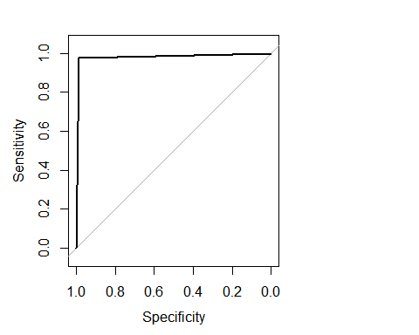

## Data: pred in 268 controls (diagnosis B) < 159 cases (diagnosis M). ## Area under the curve: 0.9818

# plot.new()

**plot**(g)

**library**(caret)

*#with default prob cut 0.50*

test_data**$**pred_diagnosis <- **ifelse**(pred**<**0.5,'yes','no')

**table**(test_data**$**pred_diagnosis,test_data**$**diagnosis)

##

## B M

## no 3 155

## yes 265 4

*#training split of diagnosis classes*

**round**(**table**(train_data**$**diagnosis)**/nrow**(train_data),2)**\***100

##

## B M ## 63 37

*# test split of diagnosis*

**round**(**table**(test_data**$**diagnosis)**/nrow**(test_data),2)**\***100

|  |  |  |  |
| --- | --- | --- | --- |
| ##  ## B M ## 63 37  *#predicted split of diagnosis*  **round**(**table**(test_data**$**pred_diagnosis)**/nrow**(test_data),2)**\***100  ##  ## no yes ## 37 63  *#create confusion matrix #confusionMatrix(test_data$diagnosis,test_data$pred_diagnosis) #how do we create a cross validation scheme*  control <- **trainControl**(method = 'repeatedcv',  number = 10,  repeats = 3)  seed <-7  metric <- 'Accuracy'  **set.seed**(seed)  fit_default <- **train**(diagnosis**~**.,  data = train_data, method = 'glm', metric =metric , trControl = control)  **print**(fit_default)  ## Generalized Linear Model ##  ## 427 samples  ## 30 predictor  ## 2 classes: 'B', 'M' ##  ## No pre-processing  ## Resampling: Cross-Validated (10 fold, repeated 3 times) ## Summary of sample sizes: 384, 384, 385, 384, 385, 384, ... ## Resampling results:  ##  ## Accuracy Kappa  ## 0.9516242 0.8968547  **library**(caret) **varImp**(step_fit) | | |  |
| ## |  | Overall |  |
| ## | concavity_mean | 0.04016248 |  |
| ## | `concave points_mean` | 0.04060020 |  |
| ## | symmetry_mean | 0.04004251 |  |
| ## | smoothness_se | 0.04107363 |  |
| ## | fractal_dimension_se | 0.04113828 |  |

## texture_worst 0.04104256

## perimeter_worst 0.04095488

## compactness_worst 0.04099049

## fractal_dimension_worst 0.04099415

**varImp**(fit_default)

## glm variable importance ##

## ##

only 20 most important variables shown (out of 30)

## Overall

## texture_worst 100.00

## `\\`concave points_mean\\`` 98.74

## area_worst 91.99

## texture_se 85.62

## area_mean 79.84

## perimeter_worst 72.42

## radius_worst 71.29

## symmetry_se 70.27

## compactness_mean 64.41

## smoothness_se 57.38

## concavity_worst 53.05

## perimeter_mean 43.43

## texture_mean 42.20

## `\\`concave points_worst\\`` 32.62

## smoothness_mean 30.88

## compactness_se 29.91

## concavity_se 25.74

## `\\`concave points_se\\`` 24.75

## compactness_worst 21.91

## fractal_dimension_worst 21.67

*#4. MARS (earth package)*

*#The earth package implements variable importance based on Generalized cross validation (GCV),*

*#number of subset models the variable occurs (nsubsets) and residual sum of squares (RSS).*

**library**(earth)

## Loading required package: plotmo

## Loading required package: plotrix

## Loading required package: TeachingDemos

marsModel<-**earth**(diagnosis**~** ., data=data) *# build model* ev <- **evimp** (marsModel) *# estimate variable importance* ev

## nsubsets gcv rss

## area_worst 15 100.0 100.0

|  |  |  |  |  |  |
| --- | --- | --- | --- | --- | --- |
| ## | `concavepoints_mean` | 14 | 43.1 | 44.5 |  |
| ## | area_mean | 13 | 34.5 | 36.2 |
| ## | `concavepoints_worst` | 10 | 22.9 | 24.9 |
| ## | texture_mean | 9 | 18.2 | 20.5 |
| ## | radius_se | 8 | 13.3 | 16.2 |
| ## | symmetry_worst | 7 | 9.6 | 13.0 |
| ## | compactness_mean | 6 | 7.6 | 11.1 |
| ## | radius_worst | 2 | 1.5 | 5.1 |  |
| **plot.new**() **plot** (ev) | | | | | |

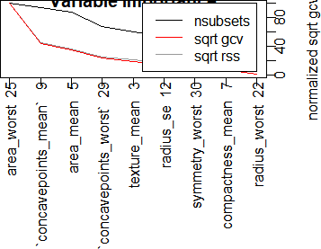

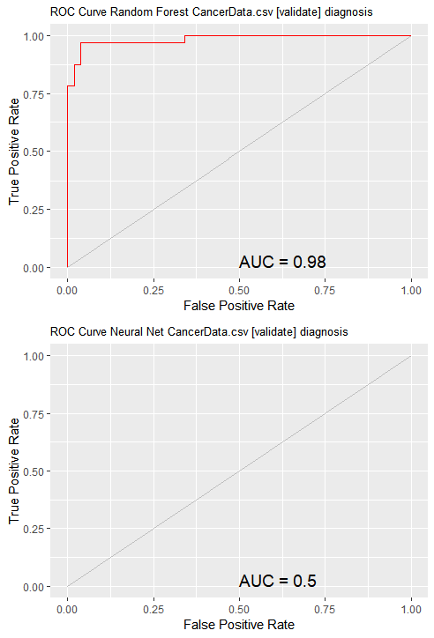

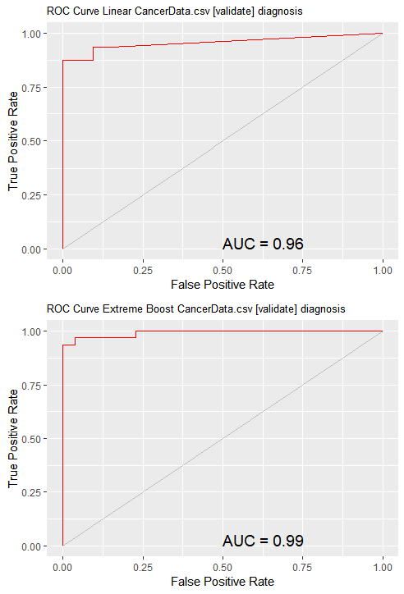

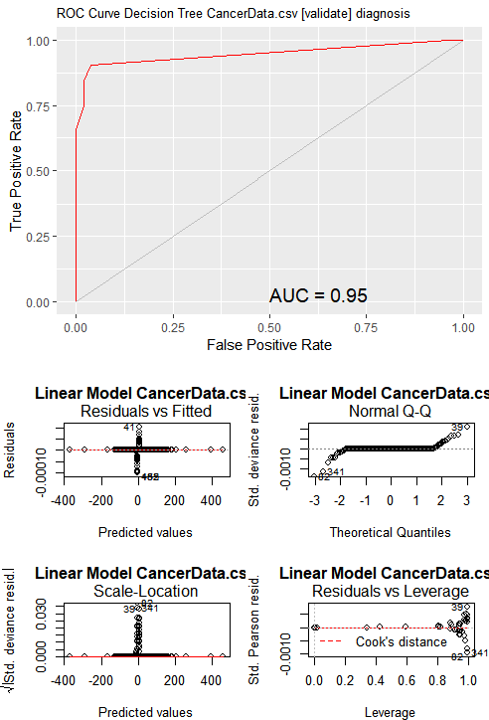

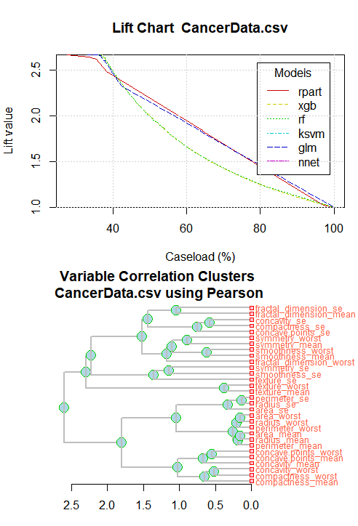

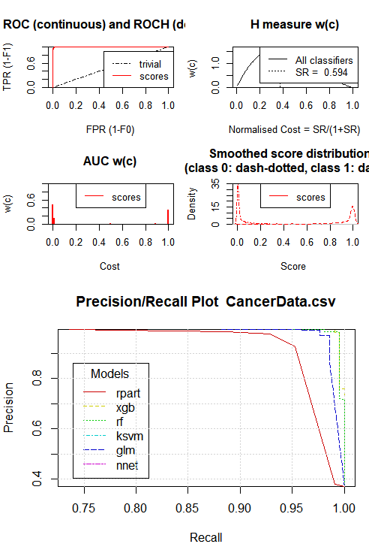

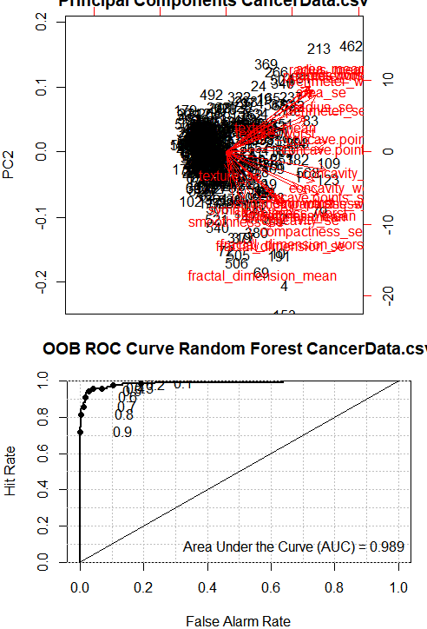

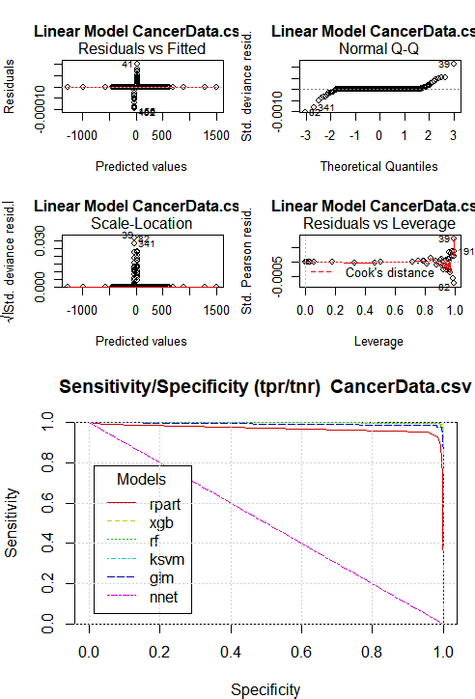

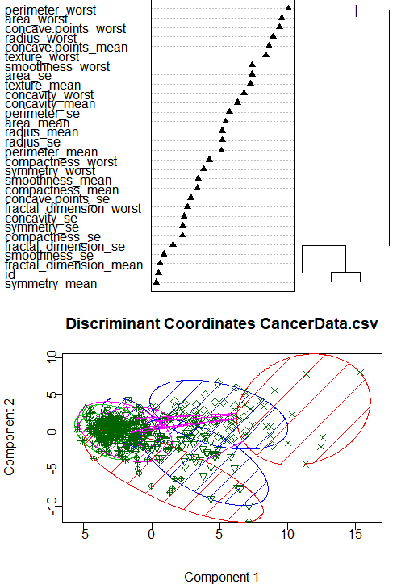

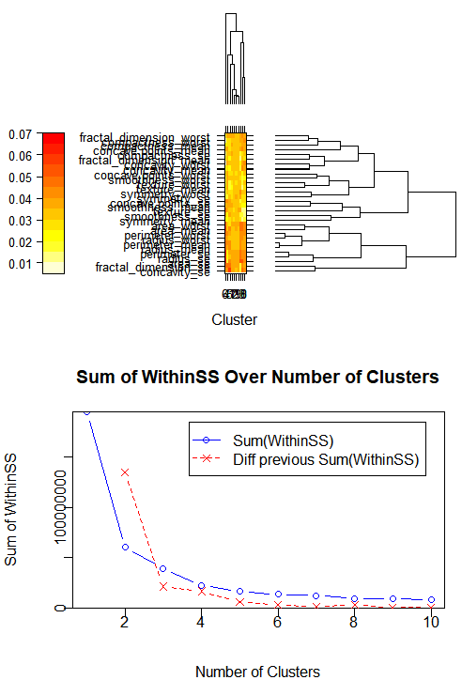

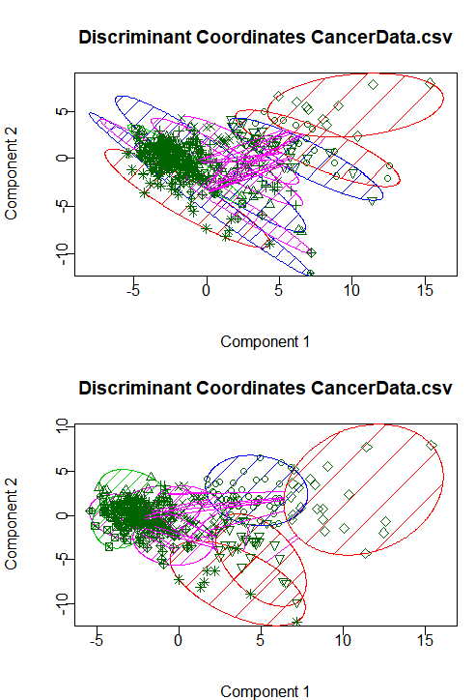

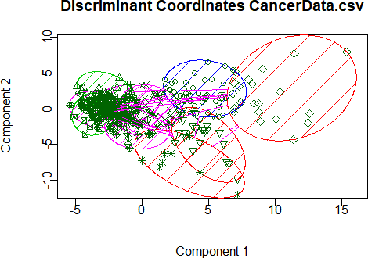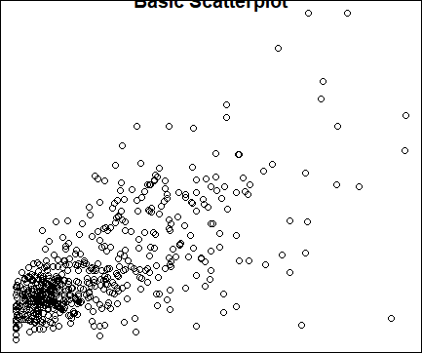

Other plots through Rattle

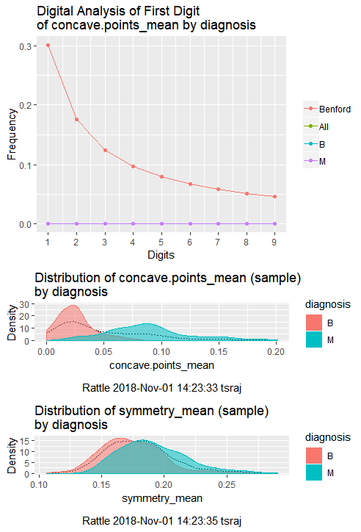

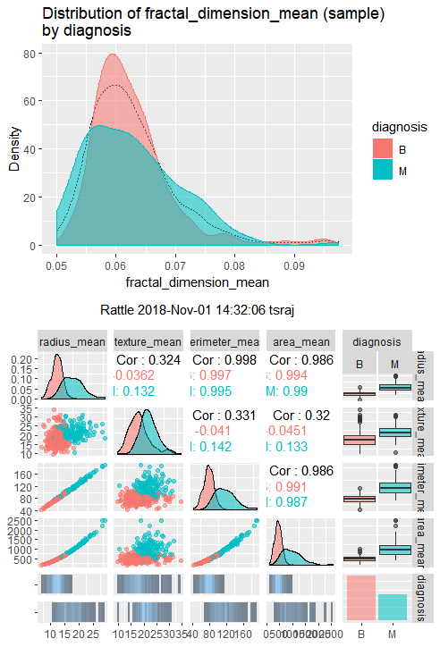

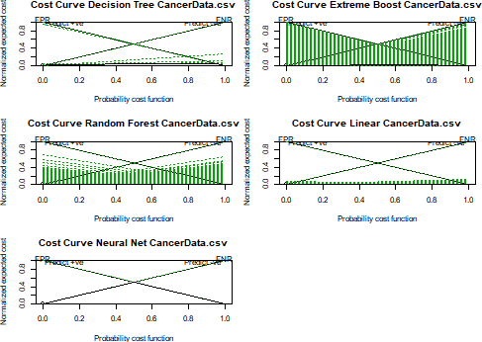

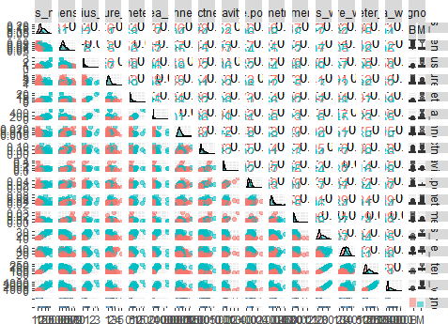

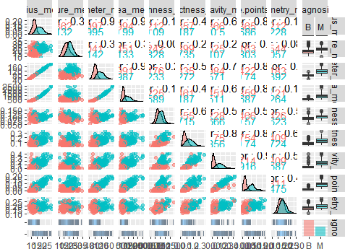

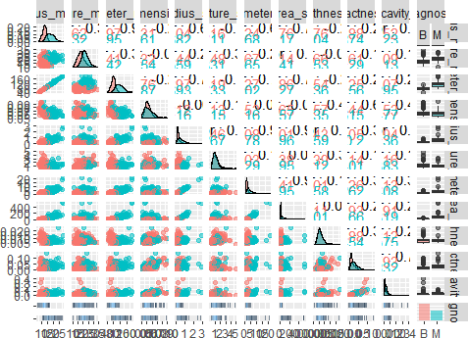

R Script

setwd("C:/Users/tsraj/Desktop/Acadgild students projects/project4")

library(readr)

CancerData <- read_csv("CancerData.csv") print(paste("rows:", nrow(df), "cols:", ncol(CancerData))) View(CancerData)

summary(CancerData) dim(CancerData) names(CancerData) #CancerData<- CancerData[-1]

CancerData$diagnosis <- factor(CancerData$diagnosis, levels = c("B", "M"),

labels = c("Benign", "Malignant")) names(CancerData)

library(mice) library(readr,dplyr) library("ggplot2") library("corrplot") library("gridExtra") library("pROC") library("MASS") library("caTools") library("caret")

library(randomForest) library(rpart) library(rpart.plot) library(rattle) library(ggplot2) library(Amelia) library(class) library(gmodels)

missmap(CancerData, main="Missing Data Map", col=c("#FF4081", "#3F51B5"),

legend=FALSE) data<-CancerData data[,33]<-NULL

barplot(table(data$diagnosis), xlab = "Type of tumor", ylab="Numbers per type")

str(data) any(is.na(data))

# visualize the missing values using the missing map from the Amelia package

missmap(data,col=c("yellow","red")) data$diagnosis<-as.factor(data$diagnosis) summary(data)

qplot(radius_mean, data=data, colour=diagnosis, geom="density",

main="Radius mean for each tumor type")

qplot(smoothness_mean, data=data, colour=diagnosis, geom="density",

main="Smoothness mean for each tumor type")

qplot(concavity_mean, data=data, colour=diagnosis, geom="density",

main="Concavity mean for each tumor type") qplot(area_worst , data=data, colour=diagnosis, geom="density",

main="area worst for each tumor type")

# Looking at distribution for area.mean variable plot.new()

hist(CancerData$area_mean,

main = 'Distribution of Cell Area Means',

xlab = 'Mean Area',

col = 'green')

#we find that the data is imbalanced and also there is a lot of corelation between the attributes

## we find that there are no missing values ## we find that data is little unbalanced prop.table(table(data$diagnosis))

## we then show some correlation corr_mat<-cor(data[,3:ncol(data)])

corrplot(corr_mat)

plot.new()

plot(data$area_mean ~data$concavity_mean) title('Basic Scatterplot')

ggplot(data, aes(x=data$area_worst)) + geom_histogram(binwidth = 1, fill = "yellow", color = "black")

ggplot(data, aes(x=data$area_mean)) + geom_histogram(binwidth = 1, fill = "green", color = "red")

#Modelling

#We are going to get a training and a testing set to use when building some models:

set.seed(1234)

data_index<-createDataPartition(data$diagnosis,p=0.75,list = FALSE)

train_data<-data[data_index,-1] test_data<-data[data_index,-1]

## Applying learning models fitControl <- trainControl(method="cv",

number = 5,

preProcOptions = list(thresh = 0.99), # threshold for pca preprocess

classProbs = TRUE,

summaryFunction = twoClassSummary) #Model1: Random Forest

#Building the model on the training data ## random forest

model_rf <- train(diagnosis~.,

train_data,

method="ranger",

metric="ROC",

#tuneLength=10,

#tuneGrid = expand.grid(mtry = c(2, 3, 6)),

preProcess = c('center', 'scale'),

trControl=fitControl)

#Testing on the testing data ## testing for random forets

pred_rf <- predict(model_rf, test_data)

cm_rf <- confusionMatrix(pred_rf, test_data$diagnosis, positive = "M")

cm_rf

# We find the accuracy of the model is 100%

#Random forest model- takes decision trees and averages them normalize<-function(x){return((x-min(x))/(max(x)-min(x)))} data$diagnosis<-as.numeric(data$diagnosis)

data_n<-as.data.frame(lapply(data,normalize)) traindata_n<--data_n[1:426,]

testdata_n<-data_n[427:569,]

rf <- randomForest(diagnosis ~., data= traindata_n, ntree =300, mtry = 5, importance = TRUE)

print(rf) plot.new()

varImpPlot(rf, type = 1, pch =8, col = 2, cex =0.8, main = "cancerdata")

abline(v= 45, col= "red") library(party)

#cf1 <- cforest(diagnosis ~ . , data=traindata_n , control=fitControl(mtry=5,ntree=300)) # fit the random forest

#varimp(cf1) # get variable importance, based on mean decrease in accuracy

#varimp(cf1, conditional=TRUE) # conditional=True, adjusts for correlations between predictors

#varimpAUC(cf1) # more robust towards class imbalance. library(Boruta)

# Decide if a variable is important or not using Boruta

boruta_output <- Boruta( diagnosis~ ., data=na.omit(train_data), doTrace=2) # perform Boruta search

boruta_signif <- names(boruta_output$finalDecision[boruta_output$finalDecision

%in% c("Confirmed", "Tentative")]) boruta_signif

#Model2: Naive Bayes #Building and testing the model model_nb <- train(diagnosis~.,

train_data,

method="nb",

metric="ROC",

preProcess=c('center', 'scale'),

trace=FALSE,

trControl=fitControl) ## predicting for test data

pred_nb <- predict(model_nb, test_data)

cm_nb <- confusionMatrix(pred_nb, test_data$diagnosis, positive = "M")

cm_nb

#Accuracy of the model is 93.9% #Model3: glm

#Building and testing the model

model_glm <- train(diagnosis~.,

train_data,

method="glm",

metric="ROC",

preProcess=c('center', 'scale'),

trace=FALSE,

trControl=fitControl)

## predicting for test data

pred_glm <- predict(model_glm, test_data)

cm_glm <- confusionMatrix(pred_glm, test_data$diagnosis, positive

= "M")

cm_glm

#Accuracy of the model is 98.3% #algorithm for decision tree library(C50)

data$diagnosis<-as.factor(data$diagnosis) tree <- C5.0( diagnosis~., data = data) summary(tree)

plot.new() plot(tree)

results <- C5.0(diagnosis ~., data = data, rules = TRUE) summary(results)

data<-as.data.frame(data) library(rpart)

tree<-rpart(diagnosis~.,data =train_data,method="class") plot(tree)

text(tree, pretty=0) library(rattle) library(rpart.plot) library(RColorBrewer) plot.new() fancyRpartPlot(tree) plot.new() printcp(tree) plotcp(tree)

ptree<- prune(tree, cp= tree$cptable[which.min(tree$cptable[,"xerror"]),"CP"])

plot.new()

fancyRpartPlot(ptree, uniform=TRUE,main="Pruned Classification Tree")

library(rpart)

fit1 <- rpart(diagnosis~.,data=train_data) fit1

summary(fit1) #Kernlab Classification require(kernlab)

installed.packages("kernlab") library(kernlab)

data_classifier<-ksvm(diagnosis ~., data =train_data , kernel='vanilladot')

data_classifier

data_predictions<-predict(data_classifier,test_data) head(data_predictions)

table(data_predictions, test_data$diagnosis) agreement<-data_predictions == test_data$diagnosis table(agreement)

prop.table(table(agreement)) agreement

set.seed(12345)

data_classifier_rbf<-ksvm(diagnosis ~., data = train_data, kernel='rbfdot')

data_predictions_rbf<-predict(data_classifier_rbf,test_data) agreement_rbf<-data_predictions_rbf == test_data$diagnosis table(agreement_rbf)

prop.table(table(agreement_rbf))

# logistic regression model:

fit <- glm(diagnosis~.,data = train_data,family = binomial(link='logit'))

summary(fit) library(MASS)

step_fit <- stepAIC(fit,method='backward') summary(step_fit)

confint(step_fit) #ANOVA on base model anova(fit,test = 'Chisq')

#ANOVA from reduced model after applying the Step AIC anova(step_fit,test = 'Chisq')

#plot the fitted model plot.new() plot(fit$fitted.values)

pred_link <- predict(fit,newdata = test_data,type = 'link') #check for multicollinearity

library(car) vif(fit) vif(step_fit)

pred <- predict(fit,newdata =test_data ,type ='response') #check the AUC curve

library(pROC)

g <- roc(diagnosis ~ pred, data = test_data) g

plot.new() plot(g) library(caret)

#with default prob cut 0.50 test_data$pred_diagnosis <- ifelse(pred<0.5,'yes','no')

table(test_data$pred_diagnosis,test_data$diagnosis)

#training split of diagnosis classes round(table(train_data$diagnosis)/nrow(train_data),2)*100 # test split of diagnosis round(table(test_data$diagnosis)/nrow(test_data),2)*100 #predicted split of diagnosis

round(table(test_data$pred_diagnosis)/nrow(test_data),2)*100 #create confusion matrix #confusionMatrix(test_data$diagnosis,test_data$pred_diagnosis) #how do we create a cross validation scheme

control <- trainControl(method = 'repeatedcv',

number = 10,

repeats = 3) seed <-7

metric <- 'Accuracy' set.seed(seed)

fit_default <- train(diagnosis~.,

data = train_data,

method = 'glm',

metric =metric ,

trControl = control) print(fit_default) library(caret) varImp(step_fit) varImp(fit_default) library(woe)

library(riv)

train_data<-as.data.frame(train_data)

iv_df <- iv.mult(train_data, y="diagnosis", summary=TRUE, verbose=TRUE)

iv_df

iv <- iv.mult(train_data, y="diagnosis", summary=FALSE, verbose=TRUE)

# Plot information value summary

iv.plot.summary(iv_df)

#4. MARS (earth package)

#The earth package implements variable importance based on Generalized cross validation (GCV),

#number of subset models the variable occurs (nsubsets) and residual sum of squares (RSS).

library(earth)

marsModel<-earth(diagnosis~ ., data=data) # build model ev <- evimp (marsModel) # estimate variable importance ev

plot.new() plot (ev)